

**IT632-Software Engineering**

**Software Requirements Specifications QuickAns**

**Group 17**

**Group members:**

**202312081 Nidhi Vor**a

**202312071 Dhruv Varachhiya**

**202312090 Jeevan Rajpurohit**

**202312112 Gunjan Sethi**

Index

|  |  |
| --- | --- |
| SR.NO | TOPICS |
| 1 | INTRODUCTION |
| 2 | PROBLEM STATEMENT |
| 3 | EXPECTED OUTCOME |
| 4 | OBJECTIVES |
| 5 | DEFNITIONS,ACRONYM,ABBREVATION |
| 6 | SCOPE |
| 7 | USER STORIES |
| 8 | USE CASE |
| 9 | FUNCTIONAL AND NON FUNCTIONAL REQUIREMENTS |
| 10 | FEASIBILITY STUDY |
| 11 | HARDWARE AND SOFTWARE REQUIREMENT |
| 12 | UML DIAGRAM |
| 13 | SEQUENCED DIAGRAM |
| 14 | ACTIVITY DIAGRAM |
| 15 | CLASS DIAGRAM |
| 16 | SYSTEM FLOWCHART |
| 171 | DATA DICTIONARY |
| 18 | ER DIAGRAM |
| 19 | DATA FLOW DIAGRAM |
| 20 | USER INTERFACE |
| 21 | ASSUMPTION |
| 22 | BIBLIOGRAPHY |

**Software Requirements Specification (SRS) for QuickEns**

# 1.Introduction

* The QuickAns system is a web-based platform designed to provide ITrelated assistance and knowledge sharing, and aims to revolutionize knowledge exchange in the digital age. It aims to connect users with experts in the field who can provide answers to their queries and facilitate learning within the IT community .

* QuickAns offers round-the-clock accessibility, expert-driven responses, and personalized notifications. Catering to students, developers, and industry professionals.

**1.1 Problem Statement :**

 **Lack of Centralized Expertise**: Current systems fail to provide a centralized platform where users can readily access expert knowledge and assistance in the field of IT. This fragmentation leads to inefficiencies and delays in problem-solving.

* Not Available 24 x 7.
* Users cannot get solutions from Experts.
* They can not get notification for any question.
* They cannot get a fully detailed Answer.
* They cannot get related details of the question..

**1.2 Expected outcomes :**

 **Comprehensive Knowledge Hub**: QuickAns endeavors to establish itself as a comprehensive repository of IT-related information, catering to a diverse range of topics, queries, and discussions within the IT community.

**Vibrant Community Interaction**: The platform aims to facilitate active engagement and interaction among users, fostering a vibrant community where individuals can freely exchange ideas, seek assistance, and contribute their expertise.

* QuickAns is a website where users ask the question and give the answer online.
* Available 24x7.
* Users can Ask questions and get answers from experts.
* They can get notification only for interested subjects.
* They can get fully detailed answers. ➢ They can get related details of the question

**1.3 Objectives :**

* This portal provides services for IT Students as well as developers and faculties.
* Users can get more information at one place instead of going through multiple google searches and links.
* Registered users can ask questions or doubt and registered users as well expert users can give the answer.
* Users can get subscriptions too.
* So, the main objective of the System is to provide the best service and experience to the User with the least efforts

# 2.Definition

⮚ This portal provides services for IT Students as well as developers and faculties.

⮚ The portal facilitates interactive communication between users by allowing registered users to ask questions or seek clarification on specific topics. Expert users, along with other registered users, can provide answers, insights, and solutions to these queries, fostering a collaborative learning environment.

⮚ Users can get more information at one place instead of going through multiple google searches and links.

⮚ Registered users can ask questions or doubt and registered users as well expert users can give the answer.

⮚ Users can get subscriptions too.

⮚ So, the main objective of the System is to provide the best service and experience to the User with the least efforts.

# 3.Scope

**3.1 Digital Era Accessibility**: With the increasing trend of digitalization, people are increasingly relying on online platforms to find solutions to their queries and problems. This system aims to tap into this trend by providing a platform where users can seek assistance and knowledge online.

**3.2 Target Audience**: The system is designed to cater to a diverse audience, including students, developers, and faculties. This broad user base ensures that the platform offers a wide range of expertise and knowledge areas.

**3.3 Question Collection and Notification**: One of the key functionalities of the system is to collect questions from users across various topics and notify them about relevant answers. This ensures that users stay informed about responses to their queries in a timely manner.

**3.4 User-Generated Answers**: Registered users have the opportunity to provide answers to questions posed by others. This crowdsourced approach allows for a diverse range of perspectives and solutions to be presented.

**3.5 Expert Verification**: To ensure the credibility and reliability of the answers provided on the platform, responses from registered users are verified by expert users. This verification process adds an extra layer of assurance for users seeking accurate information.

Overall,the scope of the system encompasses facilitating knowledge exchange providing timely assistance, and ensuring the quality and reliability of information shared within the online community

# 4.UserStories

● **ACTORS**

1. **ADMIN**
2. **REGISTERED USER**
3. **EXPERT USER**
4. **VISITOR**

**1.Admin :**

* As an admin, I want a login and a logout functionality that separates the admin from the rest of the users.
* As an admin, I want a profile feature that allows me to insert,edit personal information.
* As an admin, I want to be able to manage multiple users so that i can have control over the content being shared on the platform.
* As an admin, I want to be able to view the payment status of every user so that I can confirm their payment.
* As an admin, I want to be able to manage categories so that I can edit and add multiple categories of topics.
* As an admin, I want to be able to manage questions and answers on the platform so that i can control any unwanted content from being posted on the platform.
* As an admin, I want to be able to have search functionality so that I can easily look for things that I want to .
* As an admin,I want to be able manage feedback from the user so that i can improve the functionality of the platform.

**2.Registered User**

* As a registered user, I want to be able to register on the platform if i am not a registered user
* As a registered user, I want to be able to login and logout of the platform as per my requirement.
* As a registered user, I want to be able to reset my password if I am unable to login with my old password with the help of forgotten password functionality.
* As a registered user, I want to be able to have my own personal profile where I can edit my personal information.
* As a registered user, I want to be able to buy a subscription to the platform.
* As a registered user, I want to be able to ask questions on the platform
* As a registered user, I want to be able to give answers to other users' questions and rate their answers in terms of like and dislike.
* As a registered user, I want to be able to save answers of other users if I find them fascinating. As a registered user, I want to be able to manage notifications .
* As a registered user, I want to be able to search the platform based on my personal preference. As a registered user, I want to be able to give feedback on the platform

**3.Expert User**

* As an expert user, I want to be able to register on the platform as an expert user.
* As an expert user , I want to be able to login and logout from the platform as per my requirement.
* As an expert user , I want to be able to reset my password with the help of forgotten password functionality.
* As an expert user,I want to be able to select the category of which I am expert of .
* As an expert user, I want to be able to upload my qualifications so that it increases the credibility of my answers.
* As an expert user, I want to be able to give answers to the questions posted on the platform ● As an expert user , I want to be able to manage notifications.
* As an expert user, I want to be able to search through the platform.
* As an expert user, I want to be able to give feedback on the platform so that i can contribute to make the platform better.

**4.Visitors**

* As a visitor, I want to be able to view the website so that I can look at the platform. ● As a visitor, I want to be able to search through the platform.

# 5)Use Cases

**5.1 User Registration :**

* Actors: Visitor, Admin
* Description: Visitor registers on the QuickAns platform to become a registered user
* Preconditions: User has access to the internet and a compatible device.
* Basic Flow
  + - Visitor accesses the registration page.
    - Visitor fills in the required details (name, email, password, etc.).
    - Visitor submits the registration form.
    - Admin verifies the details and activates the user account.
* ·Alternative Flow:

➢ If the provided details are incomplete or incorrect, the system prompts the visitor to correct them.

**5.2 Login Page:**

* Actor: User
* Description: Users can log in to their account to access the streaming service.
* Preconditions: User has already registered an account on the platform.
* Basic Flow:
  + - * + User navigates to the login page.
        + User enters their email and password.
        + User clicks the "Login" button. ● Alternate Flows
        + If the entered credentials are incorrect, the system notifies the user to enter the correct email and password combination.

**5.3 Asking Question :**

* ·Actors: Registered User
* ·Description: A registered user asks a question on the platform.
* ·Basic Flow:
  + - * Registered users log in to their account.
      * User accesses the "Ask a Question" section.
      * User enters the question details (question text, category, attachments, etc.).
      * User submits the question. ● Activation Flow :
      * If the user encounters any issues while asking the question, they can

contact support for assistance.

·:

**5.4 Answering Questions :**

* Actors: Expert User
* Description: An expert user provides an answer to a question posted on the platform.
* Basic Flow:

Expert users log in to their account.

Expert users access the list of unanswered questions.

Expert user selects a question to answer.

Expert user drafts and submit the answer.

* ·Alternative Flow:

➢ If the expert user is unable to find suitable questions to answer, they can search for specific topics or categories.

**5.5 Subscription management :**

* Actors : Registered User, Admin
* Description: Registered users manage their subscription plans, and admin oversees subscription-related activities.
* Basic Flow:
  + - * + Registered users access the subscription management section.
        + User views available subscription plans (e.g., monthly, yearly).
        + User selects a subscription plan and proceeds to payment. ➢ User completes the payment process.
        + Admin monitors subscription payments and activates user subscriptions.

* ·Alternative Flow:

➢ If a user's subscription expires, they receive a notification prompting them to renew their subscription.

**5.6 Feedback Submission :**

* Actors :Registered User
* Description: Registered users provide feedback on their experience with the QuickAns platform ● Basic Flow:
  + - * + Registered users access the feedback submission form.
        + Users fill in the feedback form, providing details about their experience (e.g., usability, content quality).
        + User submits the feedback.
        + Admin reviews and analyzes the feedback received from users.

* ·Alternative Flow:

➢ If a user encounters any issues while providing feedback, they can contact support for assistance

# Functional and Non-

**Functional Requirements**

**6.1 Functional Requirements:**

**6.1.1 User Authentication and Registration**

* Users should be able to register and log in securely.
* User registration should collect necessary details such as name, email, and password.

**6.1.2 Asking and Answering Questions:**

* Registered users should be able to ask questions
* Experts should be able to answer questions
* Answers should be provided in detail and verified by expert users.

**6.1.3 Category Management:**

* The system should support categorization of questions into relevant topics.
* Admins should be able to manage categories.

## 6.1.4 Notifications System

* Users should receive notifications for new questions in their interested categories.
* Admins should be notified about user activities and system events.

## 6.1.5 Subscription Management

* Users should be able to subscribe to specific categories or features. ● ·Subscription payments should be processed securely.
* ·Admins should be able to manage subscriptions and view payment status.

## 6.1.6 Feedback System

* ·Users should be able to provide feedback on the system and its features.
* Admins should be able to view and analyze feedback.

## 6.1.7 User Profile Management

* Users should be able to manage their profiles, including personal details and preferences.
* Admins should have access to user profiles for moderation purposes.

## 6.1.8 Content management

* Admins should be able to moderate user-generated content, such as questions and answers.
* Inappropriate content should be flagged and removed.

**6.2 Non-Functional Requirements:**

**6.2.1 performance**

|  |  |  |
| --- | --- | --- |
| **6.2.2 Security**  **6.2.3 Scalability**    **6.2.4 Usability**    **6.2.5 Reliability** | ●  ●  ●  ●  ●  ●  ●  ●  ●  ●  ● | The system should be responsive and provide quick access to information.  Response times for queries should be minimal, even under heavy load.    User data should be stored securely and protected from unauthorized access.  Payment transactions should be encrypted and secure.    The system should be able to handle a growing user base and increasing data volume  It should be scalable both horizontally and vertically to accommodate future growth.    The user interface should be intuitive and easy to navigate.  Users should be able to find information quickly and efficiently    The system should be available 24/7 with minimal downtime for maintenance.  It should have mechanisms in place to handle errors and failures gracefully.  The system should be compatible with a range of devices and browsers.  It should provide a consistent user experience across different platforms. |
| **6.2.6 Compatibility**  ● | |

**Feasibility study**

## TECHNICLA FEASIBILITY

* QuickAns system is a web-based application. The main tools and technologies which are going to be used in QuickAns are as follows :-
* HTML
* CSS
* JQUERY
* SERVLET
* JSP
* MYSQL
* ECLIPSE
* Diagram Drawing Tools:- VISIO

Each of these technologies are freely available and the skills required are manageable.

Time limitation of the product development and the ease of implementing using these technologies are synchronized.

The resources which are required (both hardware and software) and technologies are available at no cost.

By considering all these points we can say that our system is technically feasible as minimal or no cost is required in its development and maintaining it is also quite easy.

**HARDWARE - SOFTWARE REQUIREMENTS**

* **Hardware Requirements :-**

|  |  |
| --- | --- |
| Processor | Minimum Core i3 or Higher |
| RAM | Minimum 1 GB or Higher |
| Hard Disk | Minimum 2 GB or Higher |

* **Software Requirements :-**

|  |  |
| --- | --- |
| OS | Minimum Windows 8 or Higher |
| Browser | Mozilla v65.0.2 or Chrome v73.0.3683.86 |

* **Server-Side Requirements:-**

* **Hardware Requirements :-**

|  |  |
| --- | --- |
| Processor | Minimum Core i3 or Higher |
| RAM | Minimum 5 GB or Higher |
| Hard Disk | Minimum 10 GB or Higher |

* **Software Requirements :-**

|  |  |
| --- | --- |
| OS | Minimum Windows 7 or Higher |
| Server | Apache Tomcat |
| Database | MySQL |

**SYSTEM ANALYSIS AND DESIGN**

## 4.1UML (Unified Modeling Language)

ADMIN

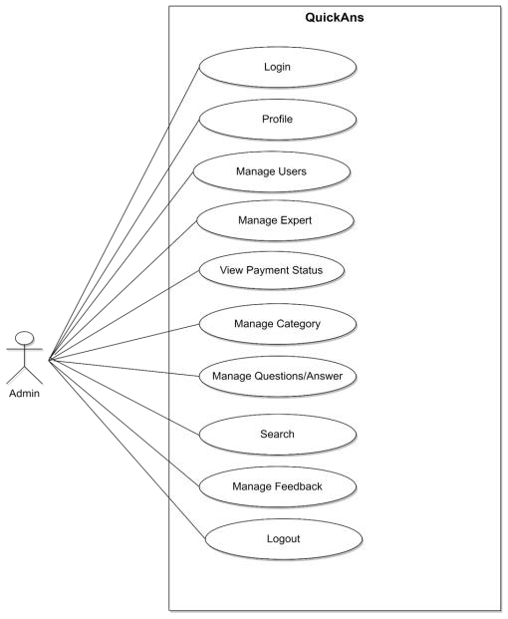

### REGISTERED USER

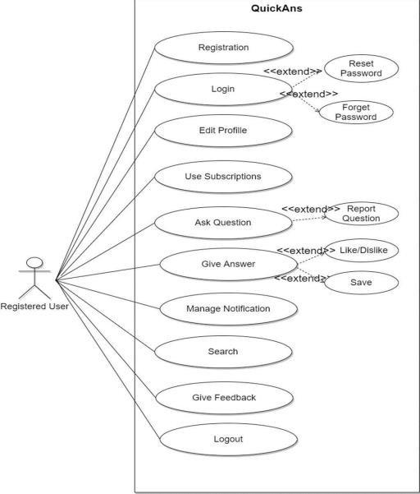

EXPERT USER

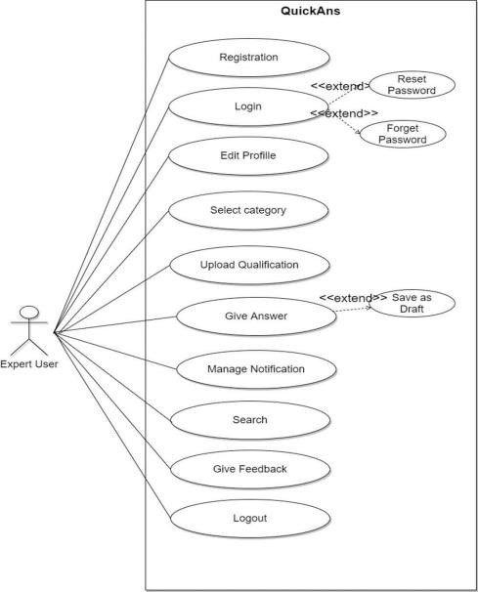

VISITOR

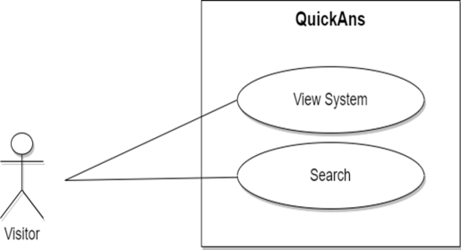

SEQUENCE DIAGRAM

1] LOGIN/REGISTRATION

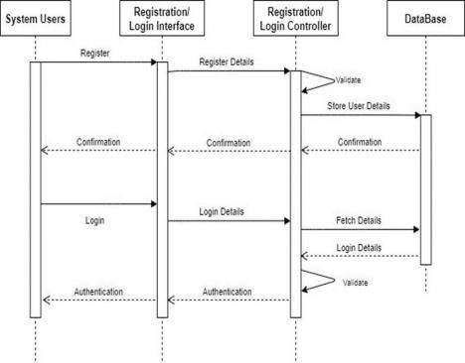

2]ADMIN

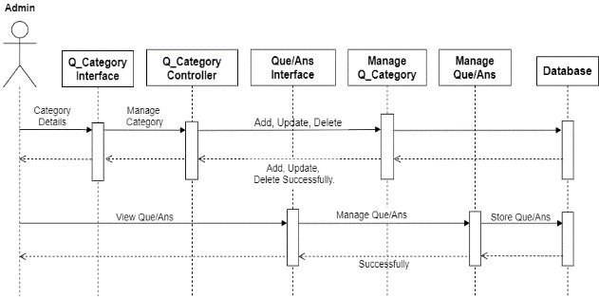

3]REGISTERED USER

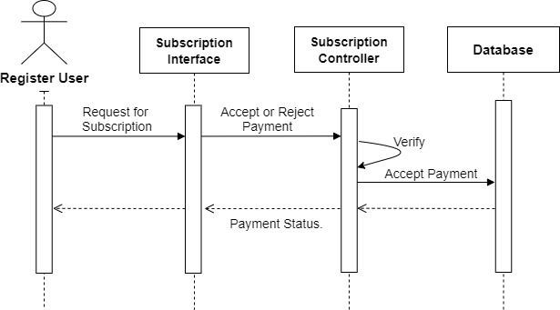

EXPERT USER

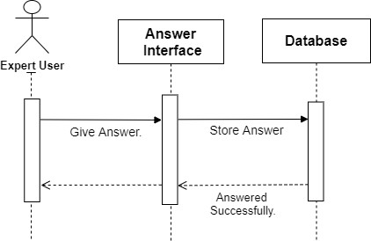

ACTIVITY DIAGRAM ADMIN

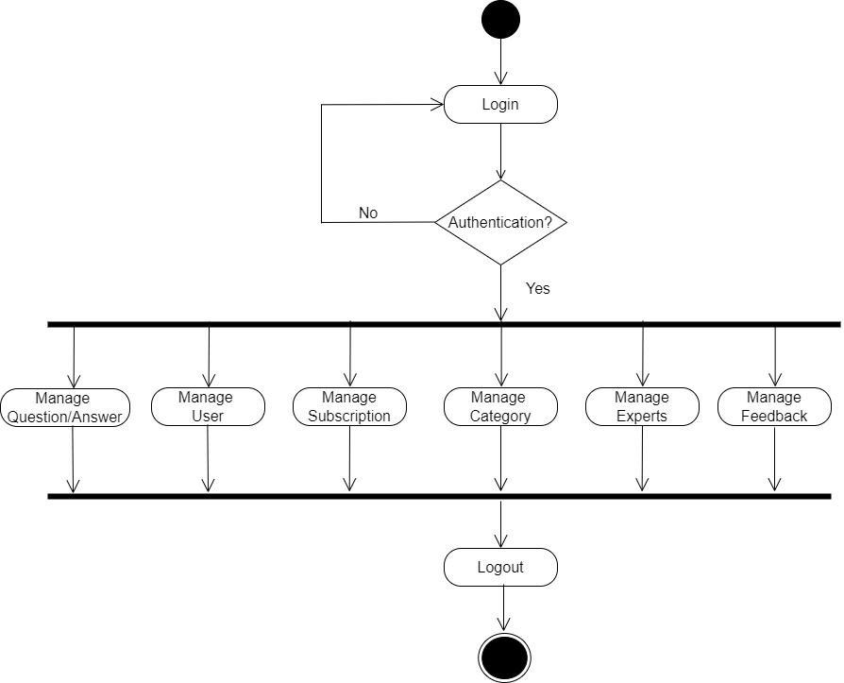

REGISTERED USER

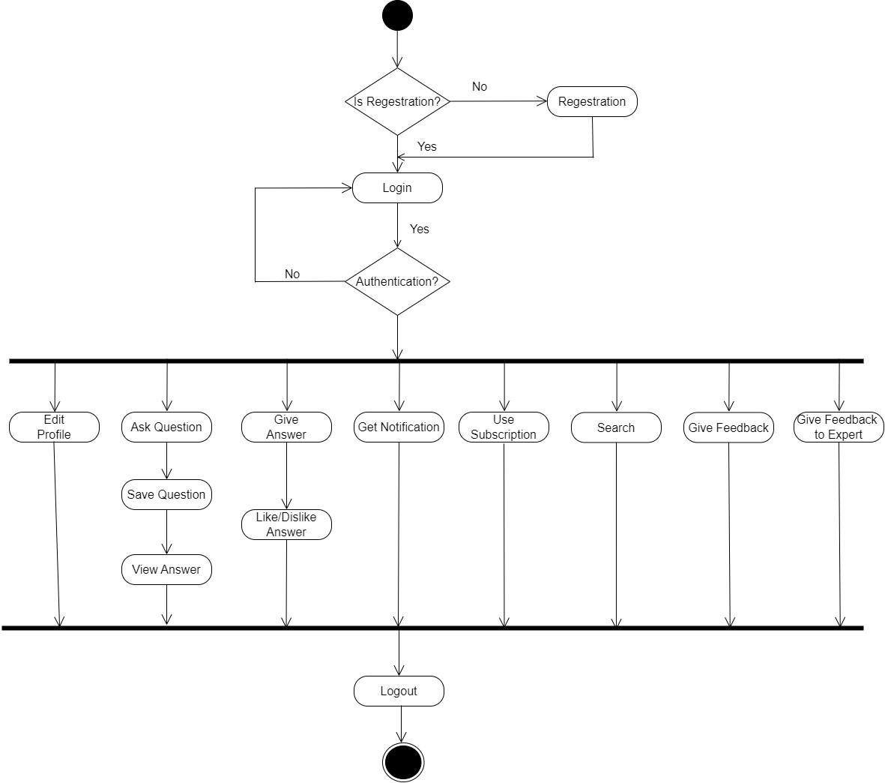

EXPERT USER

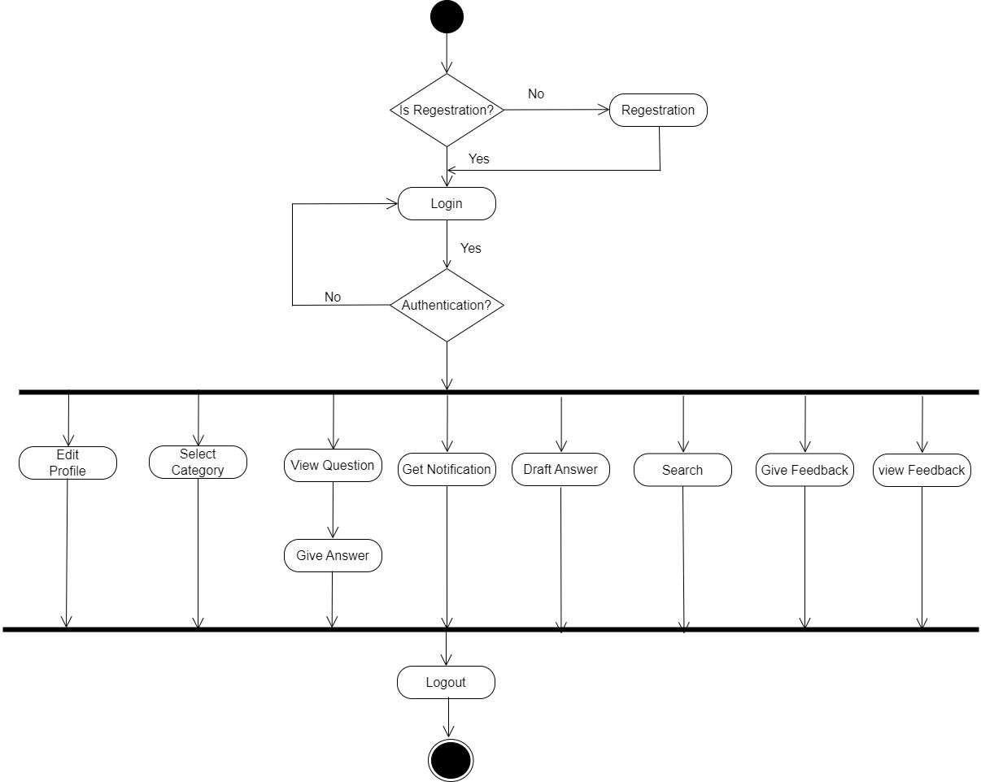

VISITOR

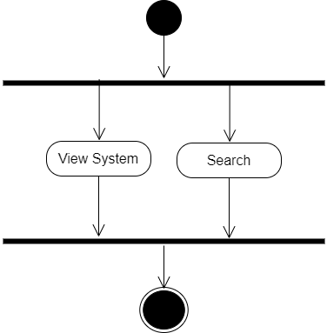

CLASS DIAGRAM

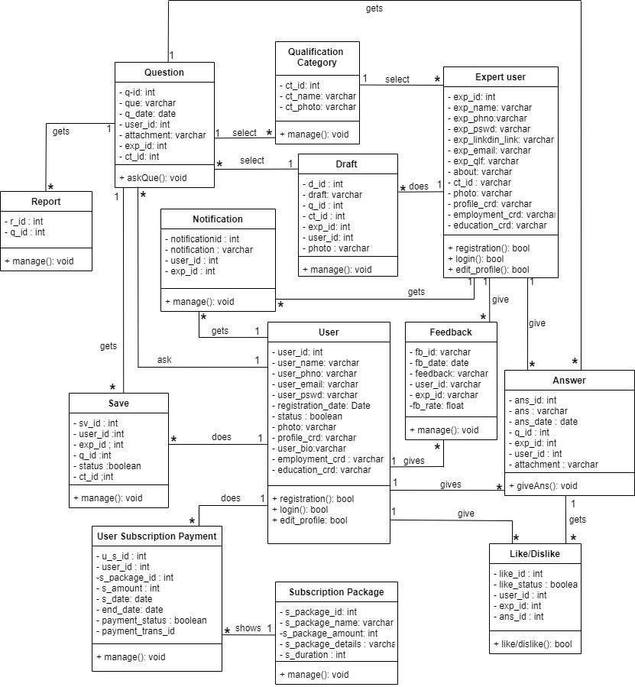

SYSTEM FLOWCHART

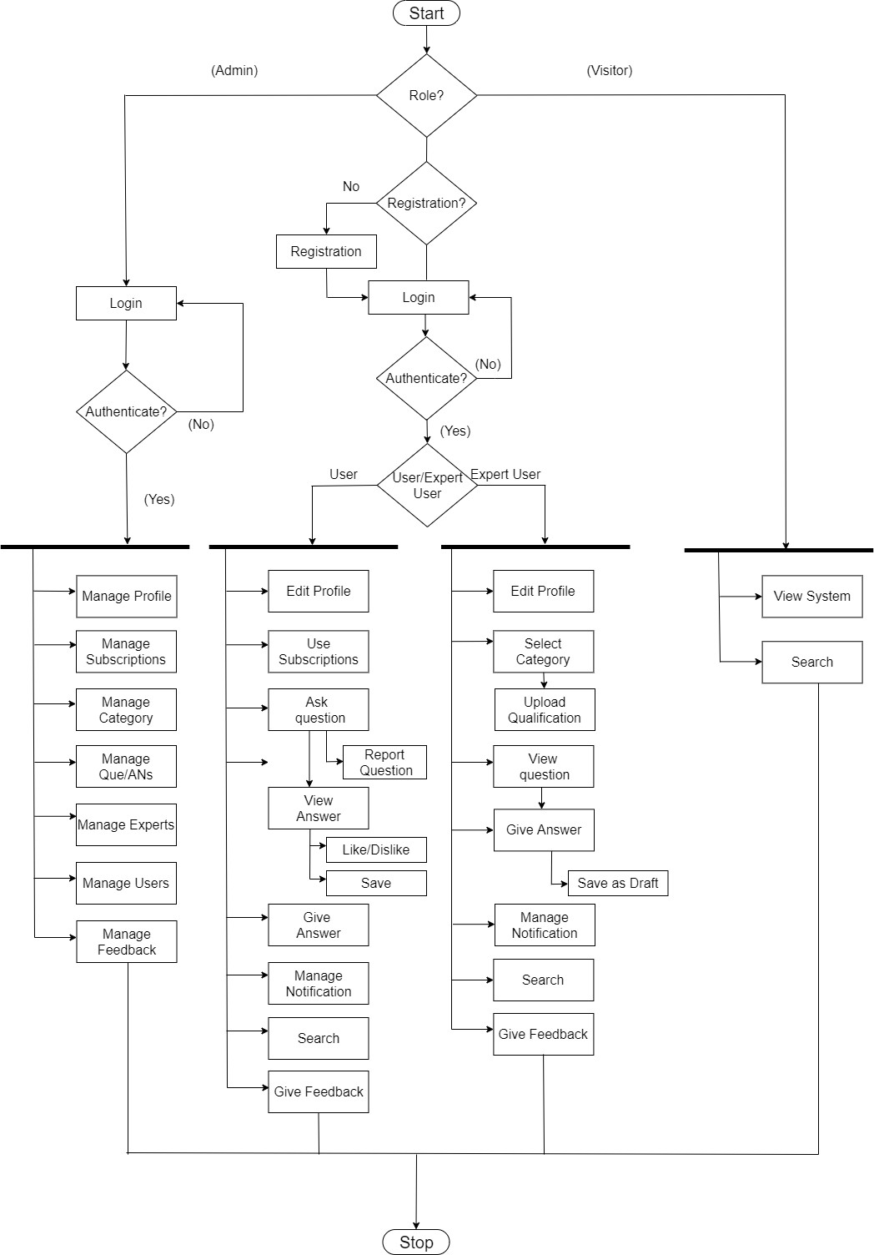

DATA DICTIONARY

**Total Tables**

1. Question Table
2. Category Table
3. Answer Table
4. Expert User Table
5. User Table
6. Notification table
7. Like_dislike Table
8. Draft Table
9. Report question table
10. Contact Table

11.Save question Table

1. Subscription Package Table
2. Subscription Payment Table
3. Feedback Table
4. Expert Rating Table

\

**Table Number :** 1

**Table Name :** Question Table

**Primary Key :** q_id

**Description :** Store Question Asked by User

|  |  |  |  |  |  |
| --- | --- | --- | --- | --- | --- |
| **Sr.No** | **Column Name** | **Data Type** | **Size** | **Constrains** | **Description** |
| 1 | q_id | int | 5 | Primary Key | Question Id |
| 2 | que | Varchar | 50000 | Not Null | Asked Question by user |
| 3 | q_date | Date | - | Not Null | Day of Question posted |
| 4 | user_id | int | 5 | Foreign Key | User Id |
| 5 | attachment | Varchar | 100 | Null | Jpeg ,png ,doc upload |
| 6 | exp_id | int | 5 | Foreign key | Expert Id |
| 7 | ct_id | int | 5 | Foreign key | Category Id |

**Table Number :** 2

**Table Name :** Category Table

**Primary Key :** ct_id

**Description :** Store Details of Category

|  |  |  |  |  |  |
| --- | --- | --- | --- | --- | --- |
| **Sr.No** | **Column Name** | **Data Type** | **Size** | **Constrains** | **Description** |
| 1 | ct_id | int | 5 | Primary Key | Category Id |
| 2 | ct_name | Varchar | 50 | Not Null | Name of course Category |
| 3 | ct_photo | varchar | 100 | null | Photo of category |

**Table Number :** 3

**Table Name :** Answer Table

**Primary Key :** ans_id

**Description :** Store Answer of Asked Question by User

|  |  |  |  |  |  |
| --- | --- | --- | --- | --- | --- |
| **Sr.No** | **Column Name** | **Data Type** | **Size** | **Constrains** | **Description** |
| 1 | ans_id | int | 5 | Primary Key | Answer Id |
| 2 | ans | Varchar | 50000 | Not Null | Show Given Answer by User |
| 3 | ans_date | Date | - | Not Null | Date of posted answer |
| 4 | q_id | Int | 5 | Foreign Key | Question Id |
| 5 | exp_id | Int | 5 | Foreign Key | Expert User Id |
| 6 | user_id | Int | 5 | Foreign Key | User Id |
| 7 | attachment | Varchar | 10 | Null | Upload jpg, png |

**Table Number :** 4

**Table Name :** Expert User Table

**Primary Key :** exp_id

**Description :** Store Details of Expert User

|  |  |  |  |  |  |
| --- | --- | --- | --- | --- | --- |
| **Sr.No** | **Column Name** | **Data Type** | **Size** | **Constrains** | **Description** |
| 1 | exp_id | int | 5 | Primary Key | Expert User id |
| 2 | exp_name | Varchar | 50 | Not Null | Name of ExpertUser |
| 3 | exp_Phno | Varchar | 10 | Unique | Expert User PhNo. |
| 4 | exp_email | Varchar | 150 | Unique | Expert User E-Mail |
| 5 | exp_pswd | Varchar | 11 | Not Null | User Password |
| 6 | exp_youtube_link | Varchar | 500 | Not Null | Show Link of User’s Youtube. |
| 7 | exp_linkdin_link | varchar | 500 | Not null | Show Link of User’s Linkedin |
| 8 | exp_qlfi | Varchar | 400 | Not Null | Show Specific Qualification Degree of Expert User. |
| 9 | about | Varchar | 500 | Not Null | Details of Expert |
| 10 | ct_id | Int | 5 | Foreign Key | Category Id |
| 11 | photo | varchar | 500 | Not null | Profile photo of expert user |
| 12 | profile_crd | varchar | 100 | Not null | Profile credential of expert user |
| 13 | employment_crd | varchar | 100 | Not null | Employment credential of expert user |
| 14 | education_crd | varchar | 100 | Not null | Education credential of expert user |

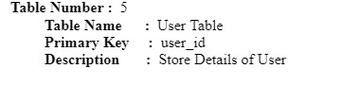

|  |  |  |  |  |  |
| --- | --- | --- | --- | --- | --- |
| **Sr.No** | **Column Name** | **Data Type** | **Size** | **Constrains** | **Description** |
| 1 | user_id | int | 5 | Primary Key | System User id |
| 2 | user_name | Varchar | 50 | Not Null | Name of User |
| 3 | user_phno | Varchar | 10 | Unique | User Phone No. |
| 4 | user_email | Varchar | 150 | Unique | User E-Mail |
| 5 | user_pwd | Varchar | 200 | Not Null | User Password |
| 6 | registration_date | Date |  | Not Null | Registration Date |
| 7 | status | boolean | - | Not null | Status of user(Whether active or not) |
| 8 | photo | varchar | 100 | Not null | Profile photo of user |
| 9 | profile_crd | varchar | 100 | null | Profile credential of user |
| 10 | user_bio | varchar | 100 | null | About of user |
| 11 | employment_crd | varchar | 100 | null | Employment credential of user |
| 12 | education_crd | varchar | 100 | Null | Education credential of user |

**Table Number :** 6

**Table Name :** Notification Table

**Primary Key :** notificationid

**Description :**  Details for notification

|  |  |  |  |  |  |
| --- | --- | --- | --- | --- | --- |
| **Sr.No** | **Column Name** | **Data Type** | **Size** | **Constrains** | **Description** |
| 1 | notificationid | int | 5 | Primary key | Notificaiton id |
| 2 | notification | varchar | 500 | Not null | Notificaiton |
| 3 | user_id | int | 10 | Foreign Key | User id |
| 4 | exp_id | int | 10 | Foreign Key | Expert id |

**Table Number :** 7

**Table Name :** Like_dislike Table

**Primary Key :** like_id

**Description :** Store Details of Liked or

Disliked Answer by User

|  |  |  |  |  |  |
| --- | --- | --- | --- | --- | --- |
| **Sr.No** | **Column Name** | **Data Type** | **Size** | **Constrains** | **Description** |
| 1 | like_id | int | 5 | Primary Key | Like Id |
| 2 | like_status | Boolean | - | Boolean | Status Of Like/Dislike |
| 3 | user_id | int | 5 | Foreign Key | User Table Primary Key |
| 4 | exp_id | int | 5 | Foreign Key | Expert User Id |
| 5 | ans_id | int | 5 | Foreign Key | Table Answer Id |

**Table Number :** 8

**Table Name :** Draft Table

**Primary Key :** d_id

**Description :**  Details for contact Package

|  |  |  |  |  |  |
| --- | --- | --- | --- | --- | --- |
| **Sr.No** | **Column Name** | **Data Type** | **Size** | **Constrains** | **Description** |
| 1 | d_id | int | 5 | Primary key | Draft id |
| 2 | draft | varchar | 1000 | Not null | draft |
| 3 | q_id | int | 5 | Foreign key | Question id |
| 4 | ct_id | int | 5 | Foreign key | Catagory id |
| 5 | exp_id | int | 5 | Foreign key | Expert id |

|  |  |  |  |  |  |
| --- | --- | --- | --- | --- | --- |
| 6  7 | user_id | int | 5 | Foreign key | User id |
| photo | varchar | 100 | null | Photo of attachment |

**Table Number :** 9

**Table Name :** Report Question table

**Primary Key :** r_id

**Description :**  Details for report question

|  |  |  |  |  |  |
| --- | --- | --- | --- | --- | --- |
| **Sr.No** | **Column Name** | **Data Type** | **Size** | **Constrains** | **Description** |
| 1 | r_id | int | 5 | Primary key | Report Question id |
| 2 | q_id | int | 5 | Foreign Key | Question id |

**Table Number :** 10

**Table Name :** Contact Table

**Primary Key :** cnt _id **Description :**  Details for Subscription Package

|  |  |  |  |  |  |
| --- | --- | --- | --- | --- | --- |
| **Sr.No** | **Column Name** | **Data Type** | **Size** | **Constrains** | **Description** |
| 1 | cnt_id | int | 5 | Primary key | Contact id |
| 2 | cnt_name | varchar | 50 | Not null | Contact name |
| 3 | Ph_no | int | 10 | Not null | Phone number |
| 4 | subject | varchar | 50 | Not null | Subject of contacting |
| 5 | message | varchar | 50 | Not null | Message |
| 6 | Cnt_email | varchar | 50 | Not null | Email |

**Table Number :** 11

**Table Name :** Save Question Table

**Primary Key :** sv_id

**Description :** Store Details for save question

|  |  |  |  |  |  |
| --- | --- | --- | --- | --- | --- |
| **Sr.No** | **Column Name** | **Data Type** | **Size** | **Constrains** | **Description** |
| 1 | sv_id | int | 5 | Primary Key | Save question Id |
| 2 | user_id | int | 5 | Foreign Key | User Id |
| 3 | exp_id | int | 5 | Foreign Key | Expert id |
| 4 | q_id | Int | 5 | Foreign Key | Question id |
| 5  6 | status | boolean | - | Not Null | Save/unsave status |
| ct_id | int | 5 | Foreign Key | Category id |

**Table Number :** 12

**Table Name :** Subscription Package Table

**Primary Key :** s_package_id

**Description :**  Details for Subscription Package

|  |  |  |  |  |  |
| --- | --- | --- | --- | --- | --- |
| **Sr.No** | **Column Name** | **Data Type** | **Size** | **Constrains** | **Description** |
| 1 | s_package_id | int | 5 | Primary Key | subscription Package Id |
| 2 | s_package_name | Varchar | 50 | Not Null | Name of Package like 6 months,12 months |
| 3 | s_package_amount | Int | 50 | Not Null | Shows Status of Transaction |
| 4 | S_pacakge_details | Varchar | 1000 | Not Null | Subscription Package details |
| 5 | s_duration | int | 5 | Not Null | Duration of subscription |

**Table Number :** 13

**Table Name :** UserSubscription Payment Table

**Primary Key :** u**_**s_id

**Description :** Store Details for Payment of Subscription

|  |  |  |  |  |  |
| --- | --- | --- | --- | --- | --- |
| **Sr.No** | **Column Name** | **Data Type** | **Size** | **Constrains** | **Description** |
| 1 | u_s_id | int | 5 | Primary Key | User subscription Id |
| 2 | user_id | int | 5 | Foreign Key | User Id |
| 3 | s_package_id | int | 5 | Foreign  Key | Subscription Package id |
| 4 | s_amount | Int | 50 | Not Null | Amount of Subscriptions |
| 6 | s_date | Date | - | Not Null | Date of Active Subscription. |
| 7 | end_date | Date | - | Not Null | Ending date of Subscription. |
| 8 | Payment_status | Boolean | - | Not Null | Activity of payment status |

**Table Number :** 14

**Table Name :** Feedback Table **Primary Key :** fb_id

**Description :** Store Details of Feedback given by User

|  |  |  |  |  |  |
| --- | --- | --- | --- | --- | --- |
| **Sr.No** | **Column Name** | **Data Type** | **Size** | **Constrains** | **Description** |
| 1 | fb_id | int | 10 | Primary Key | Feedback Id |
| 2 | fb_date | Date | - | Not Null | Date on which feed back was given |
| 3 | feedback | Varchar | 300 | Not Null | Actual Feedback |
| 4 | user_id | int | 10 | Foreign Key | User Id |
| 5 | exp_id | int | 10 | Foreign Key | Expert User Id |
| 6 | fb_rate | Float | 5 | Not Null | Feedback Rating |

|  |  |  |  |  |  |
| --- | --- | --- | --- | --- | --- |
| 9 | Payment_trans_id | Varchar | - | Not Null | Id of Transection Payment |

**Table Number :** 15

**Table Name :** Expert Rating Table

**Primary Key :** ld_id

**Description :** Store Details of Rating given to Experts by User

|  |  |  |  |  |  |
| --- | --- | --- | --- | --- | --- |
| **Sr.No** | **Column Name** | **Data Type** | **Size** | **Constrains** | **Description** |
| 1 | ld_id | int | 10 | Primary Key | Expert Rating Id |
| 2 | ld_status | tinyint | 1 | Not Null | Rating status |
| 3 | Exp_id | int | 10 | Foreign Key | Expert User Id |
| 4 | ans_id | int | 10 | Foreign Key | User Id |

ER DIAGRAM

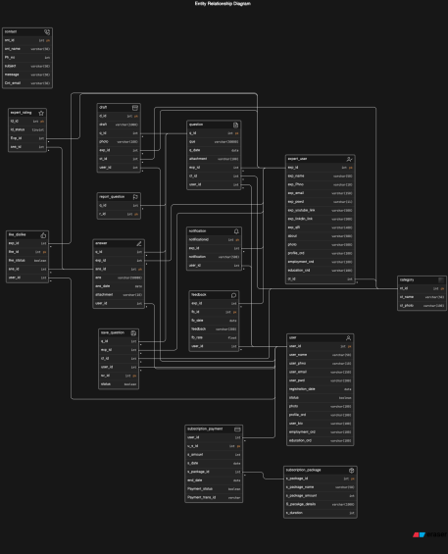

DECISION TREE :

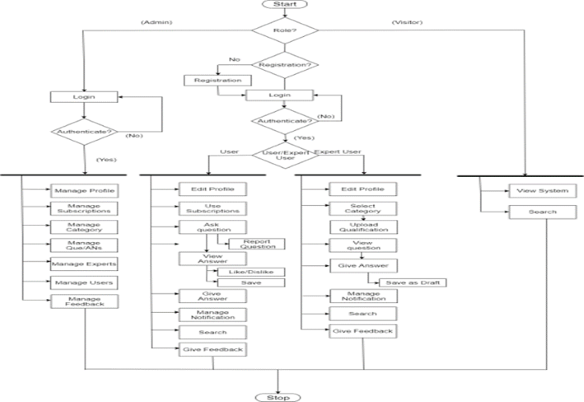

DATA FLOW DIAGRAM

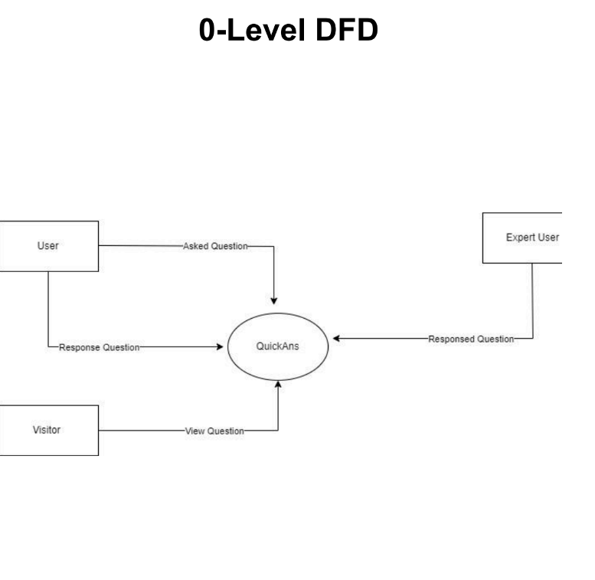

LEVEL – 1 DFD

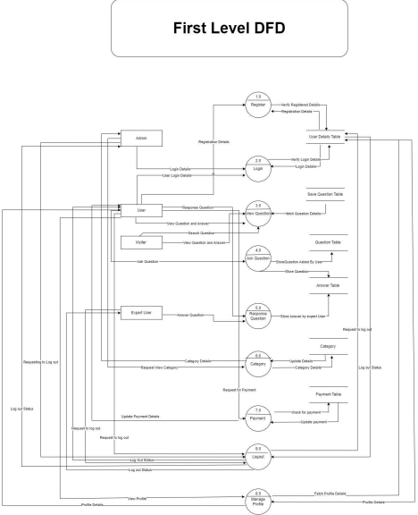

LEVEL 2 DFD ADMIN

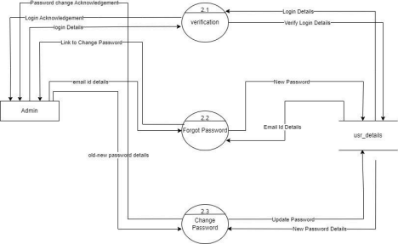

MANAGE CATEGORY

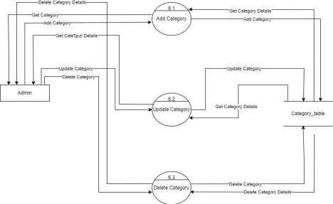

MANAGE PROFILE

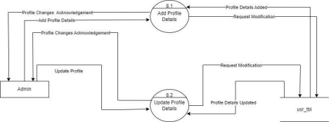

USER LOGIN

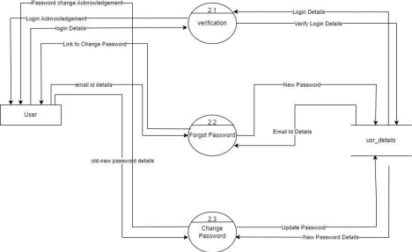

USER ACTIVITY

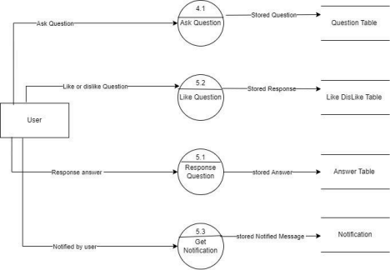

MANAGE PROFILE

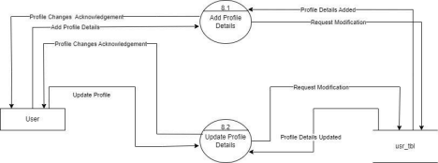

EXPERT USER LOGIN

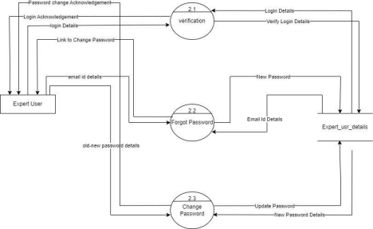

MANAGE PROFILE

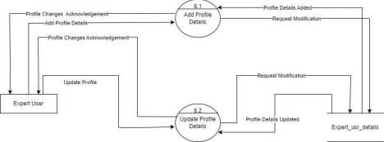

USER INTERFACE

VISITOR PAGE 1:

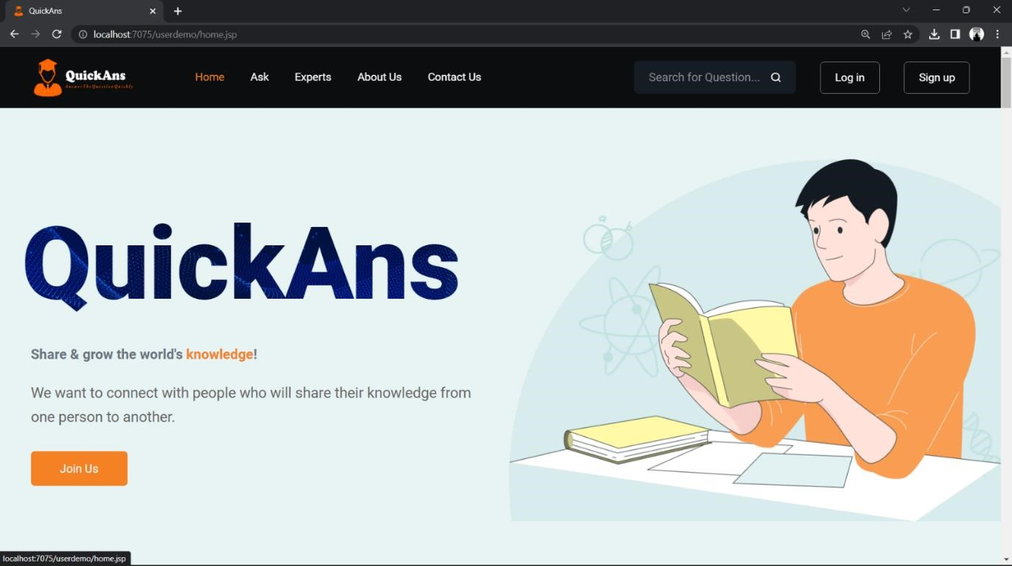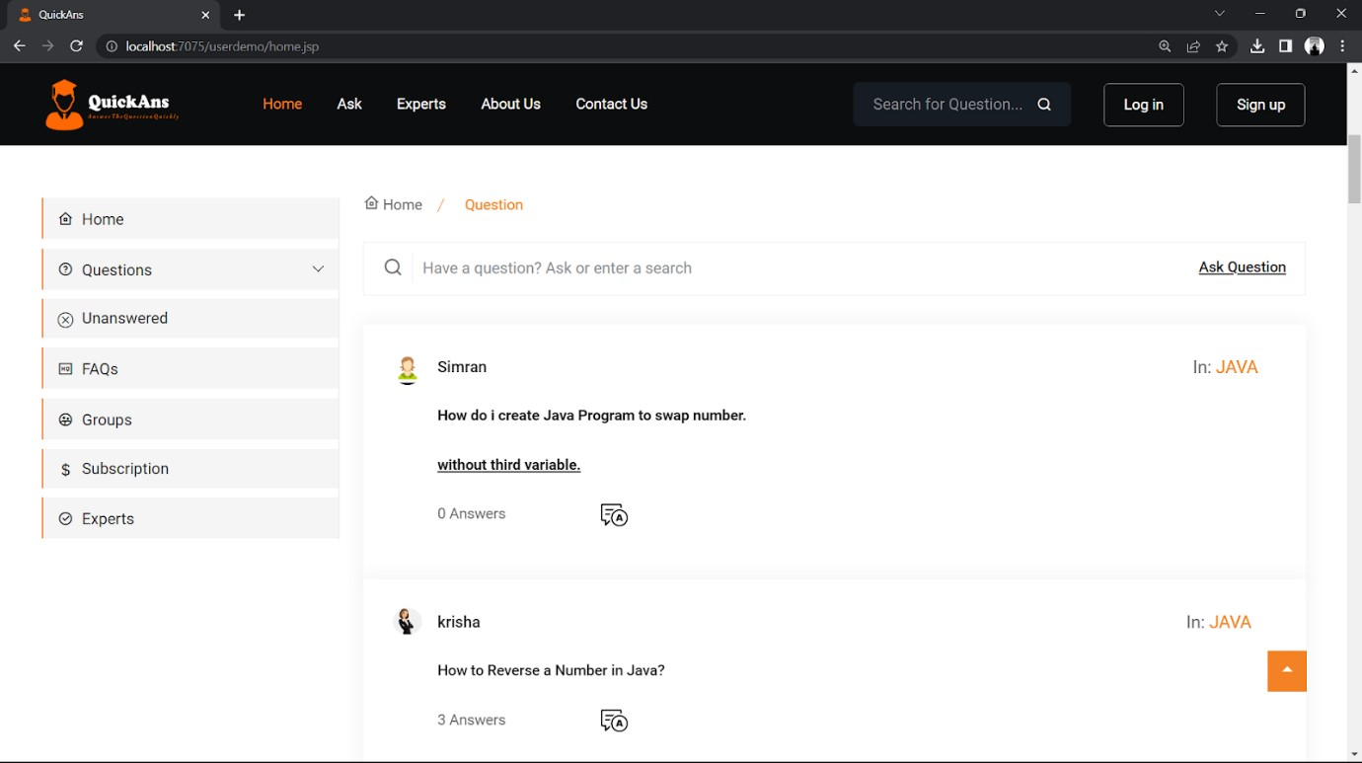

VISITOR PAGE 2:

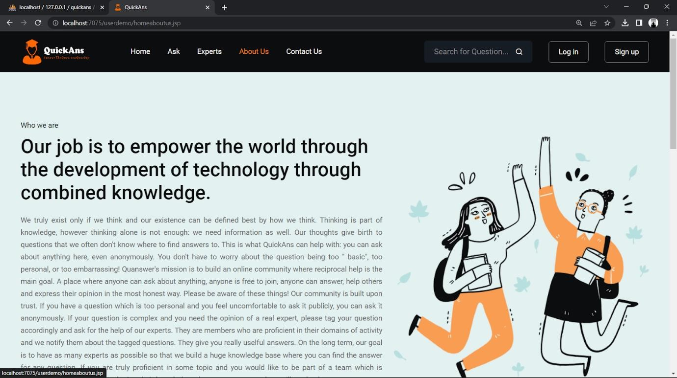

VISITOR PAGE 3:

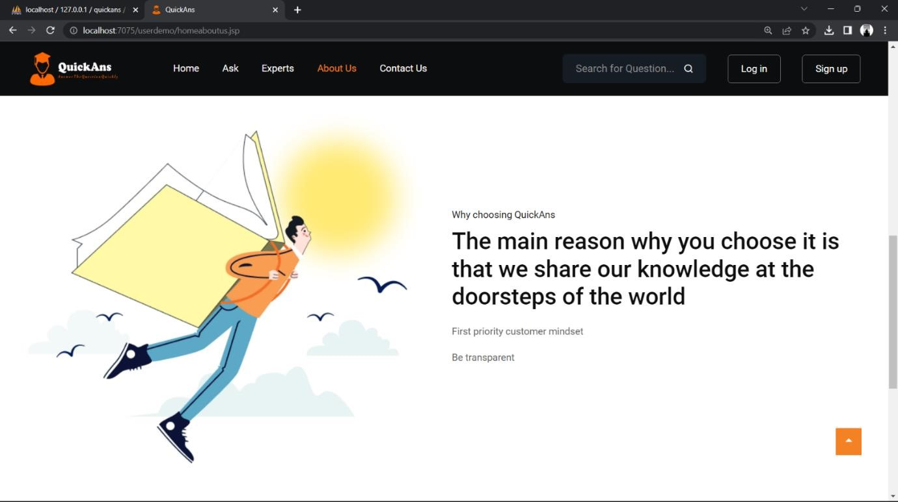

REGISTER USER

PAGE : 1

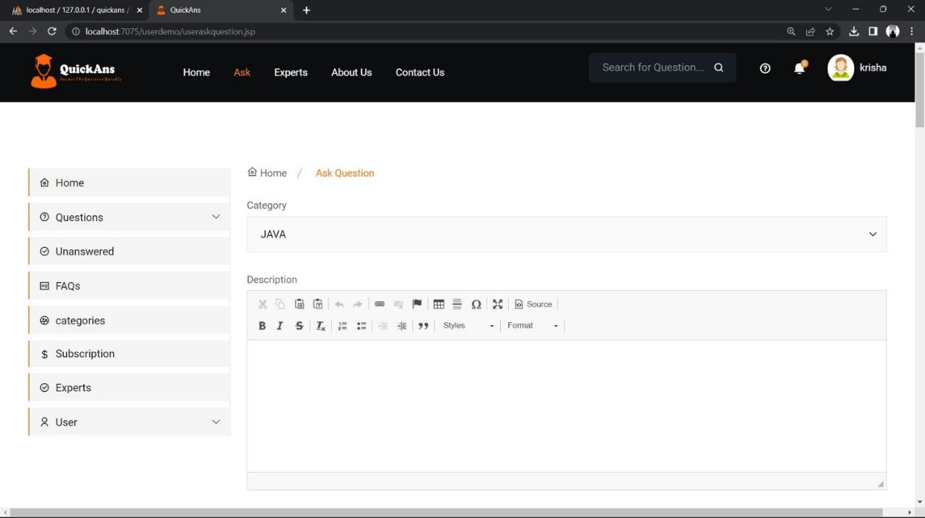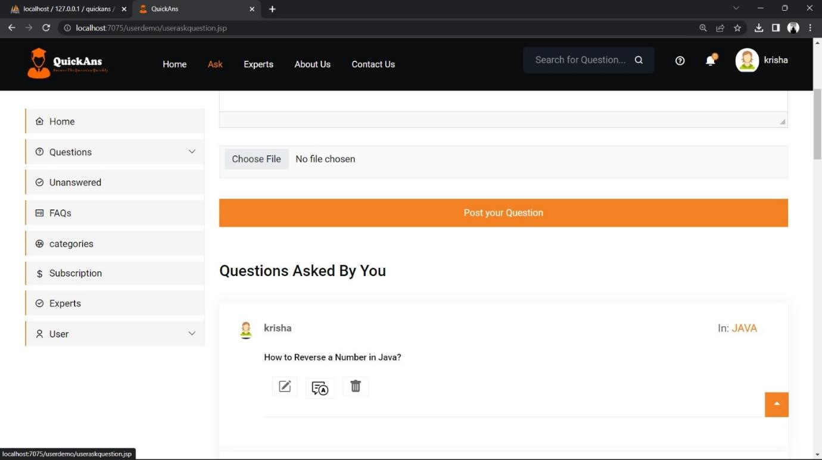

REGISTER USER PAGE : 2

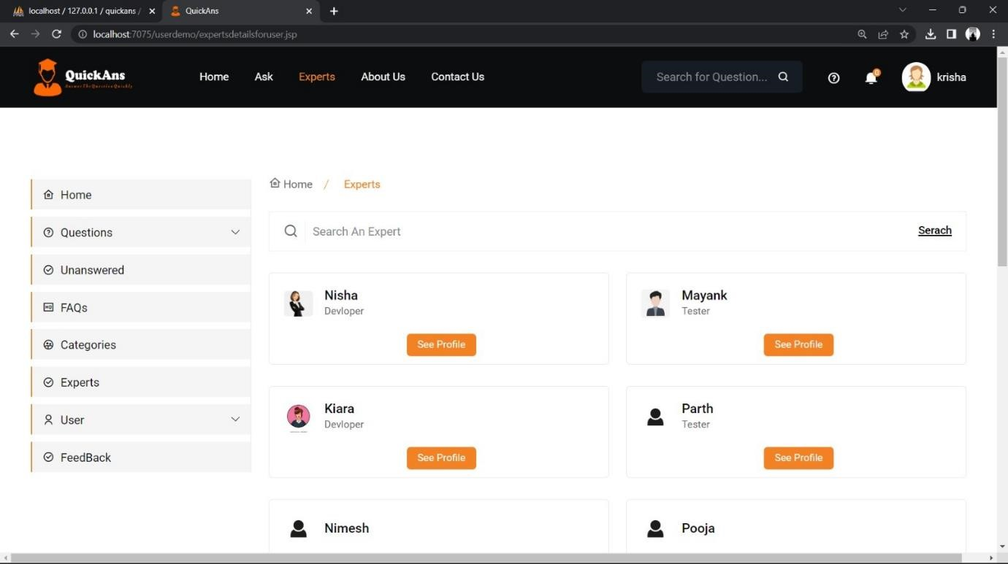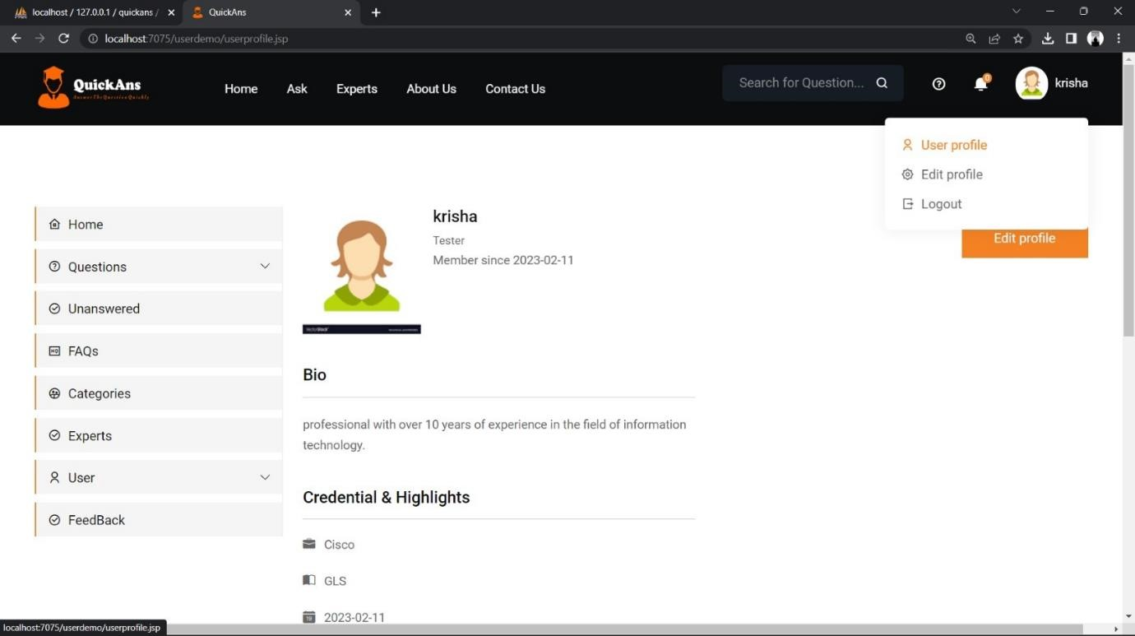

REGISTER USER PAGE : 3

EXPERT USER PAGE 1:

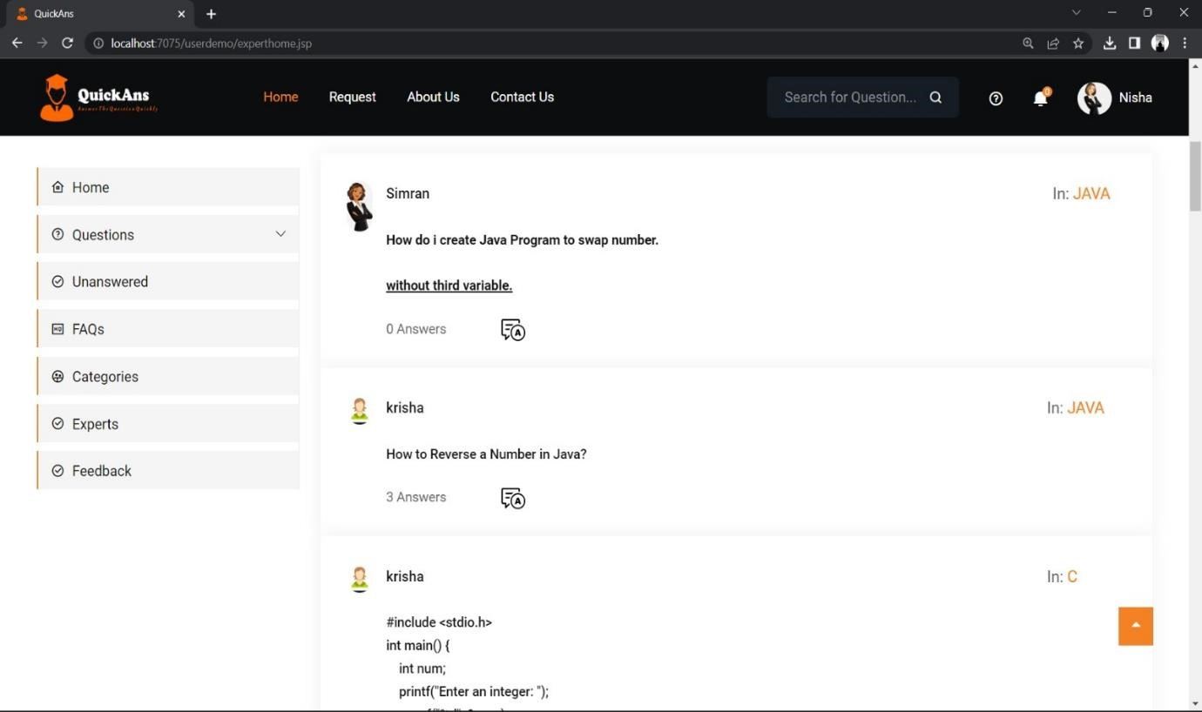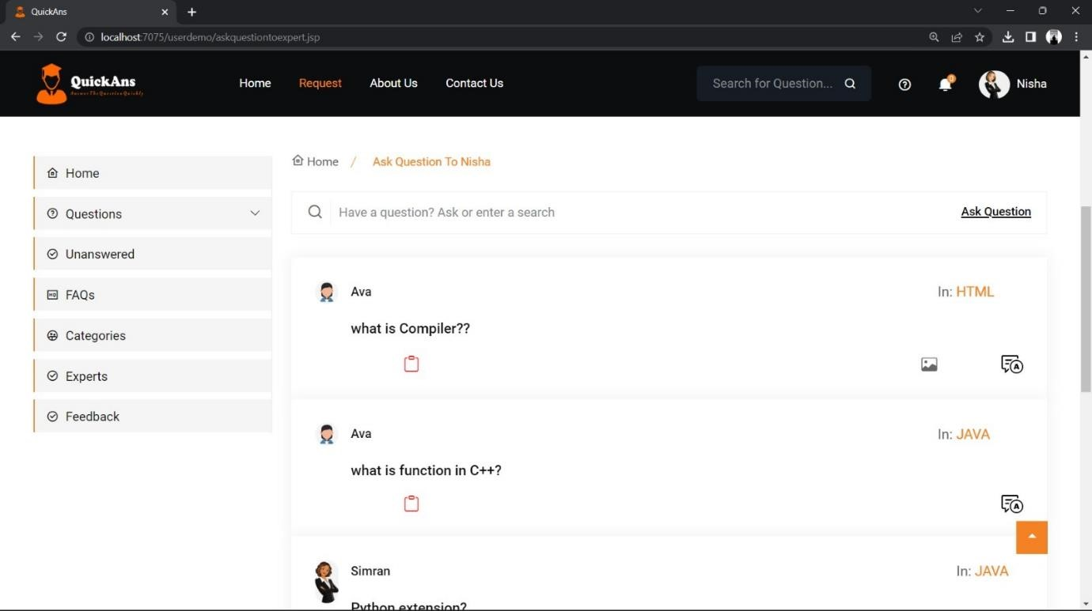

EXPERT USER PAGE 2:

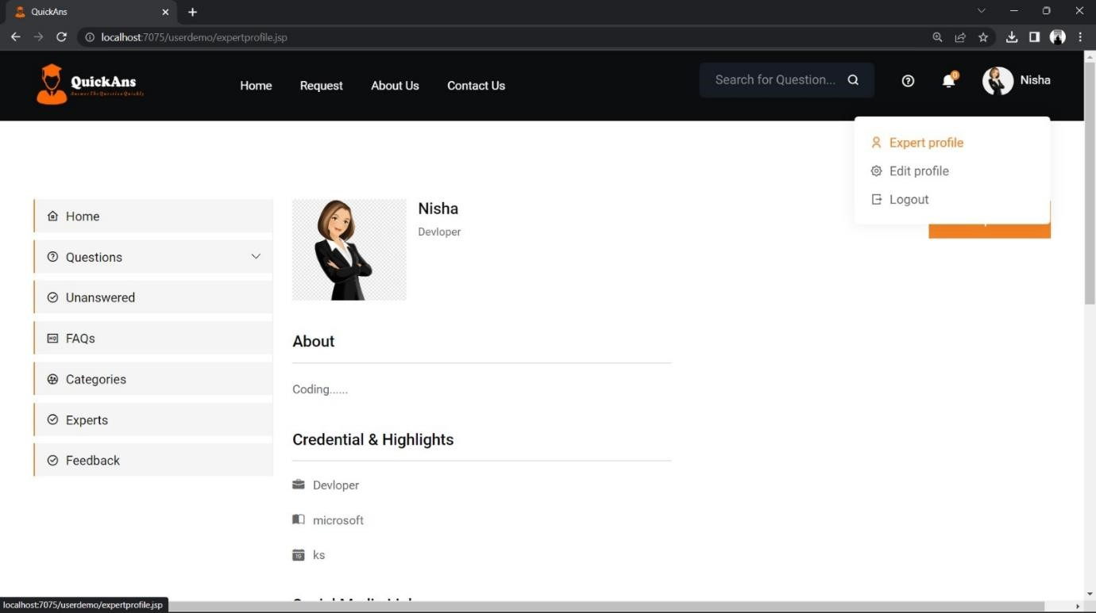

SIGN-UP PAGE

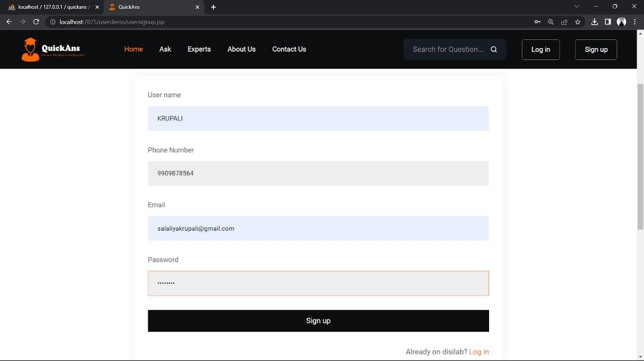

USER WILL GET OTP THROUGH MAIL

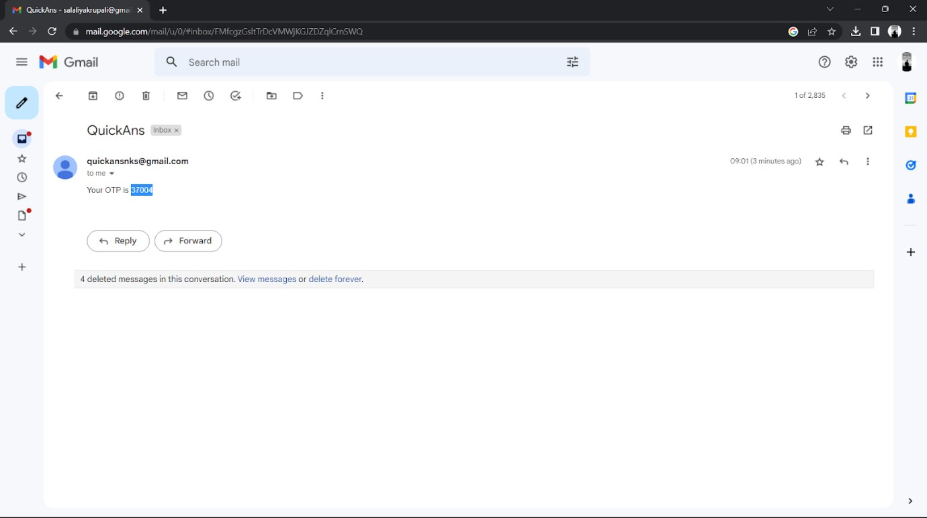

WELCOME MESSAGE TO USER

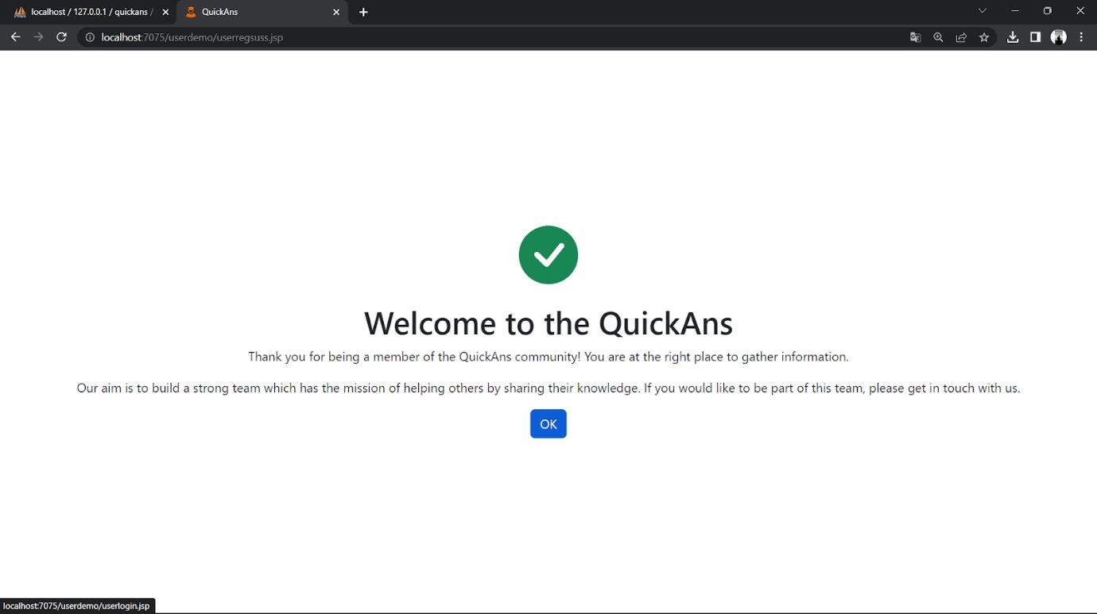

LOGIN PAGE OF USER

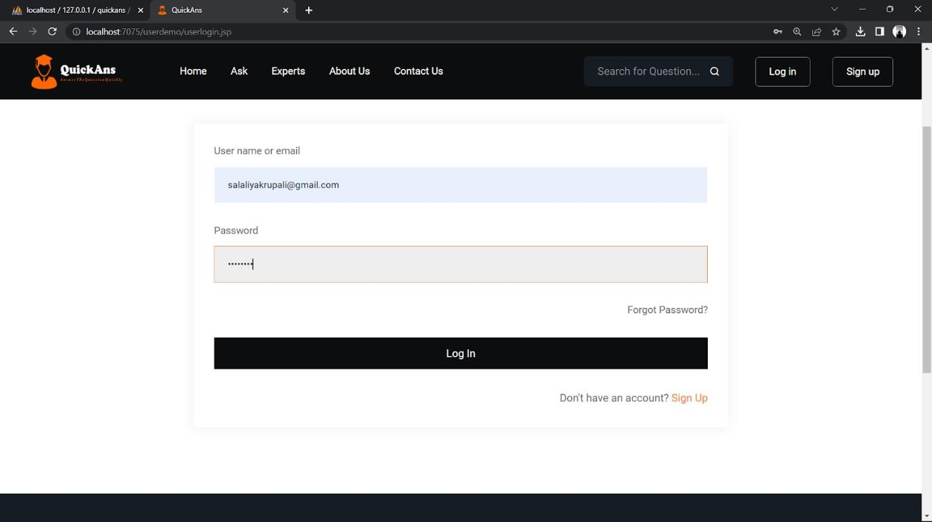

HOME PAGE OF USER

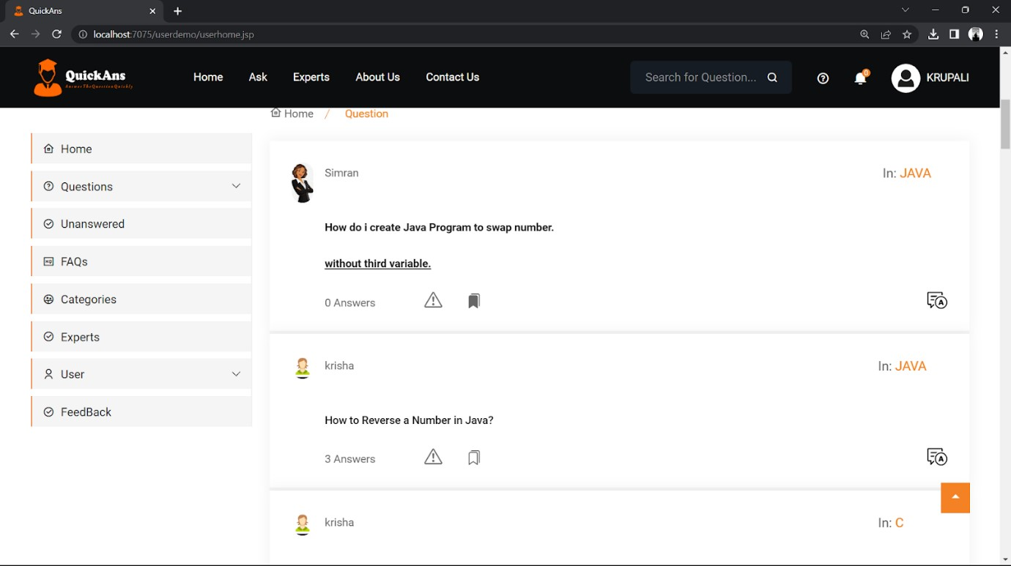

QUESTION ASKED BY USER

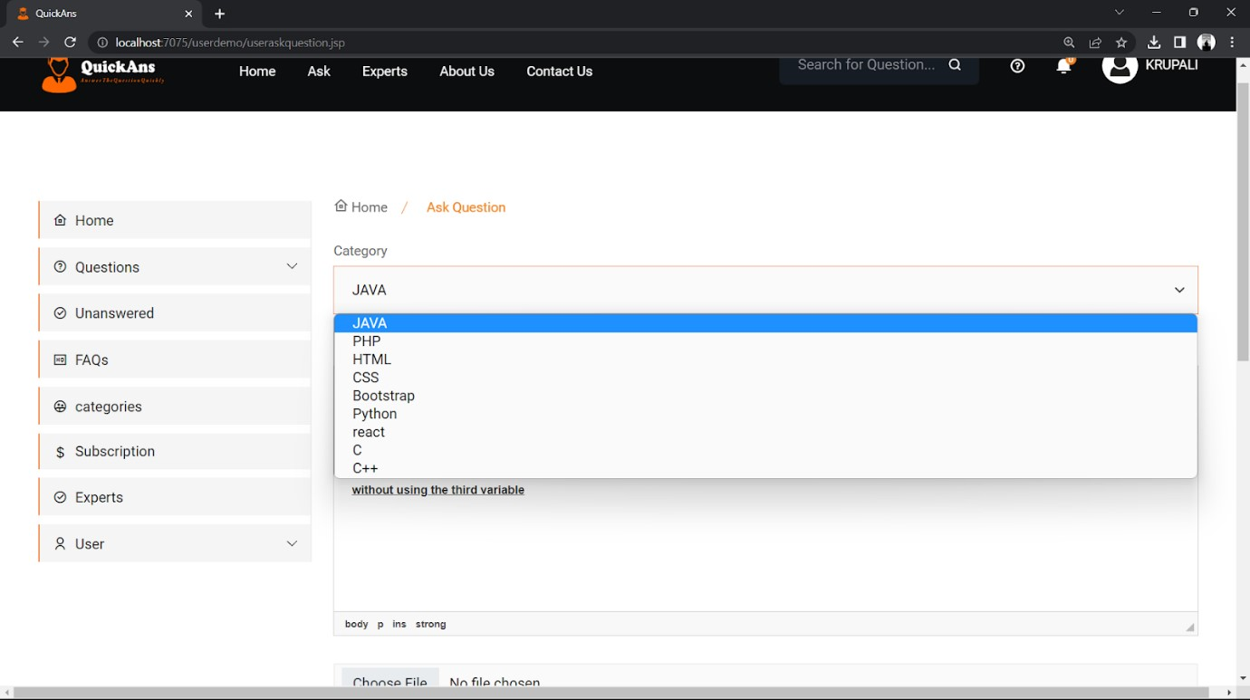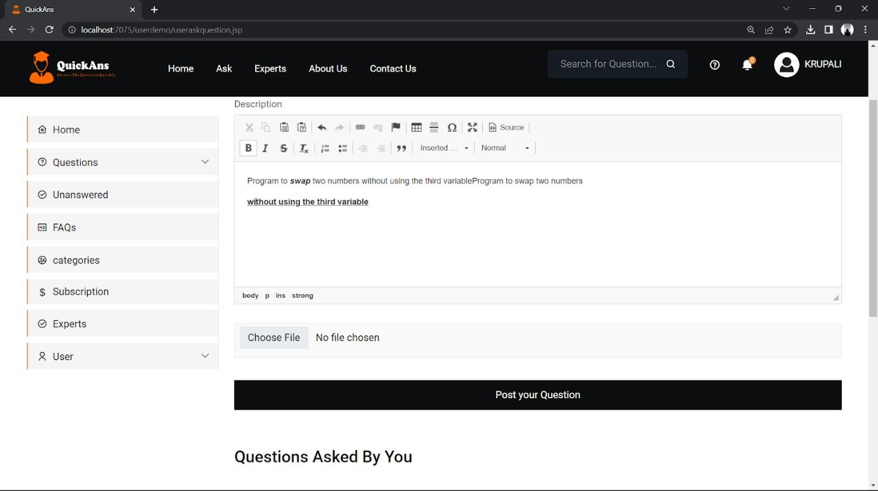

QUESTION ASKED BY USER PAGE 2:

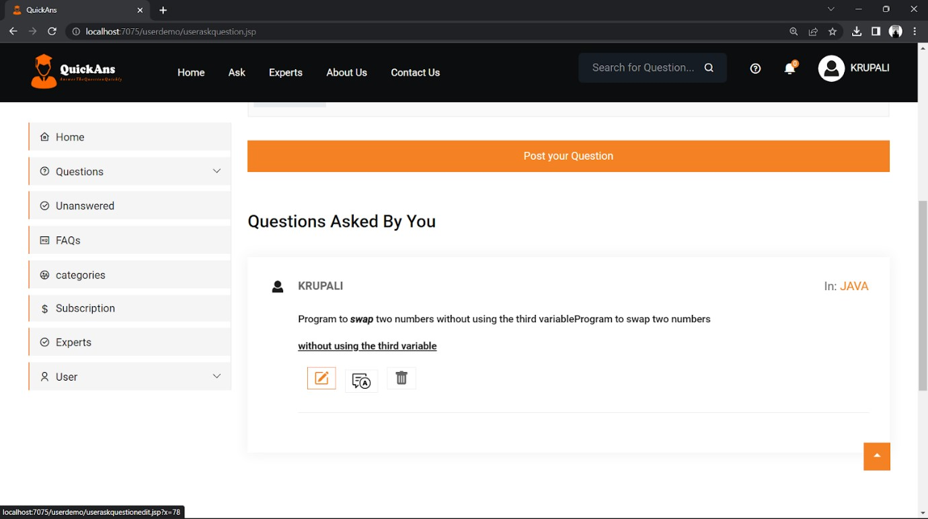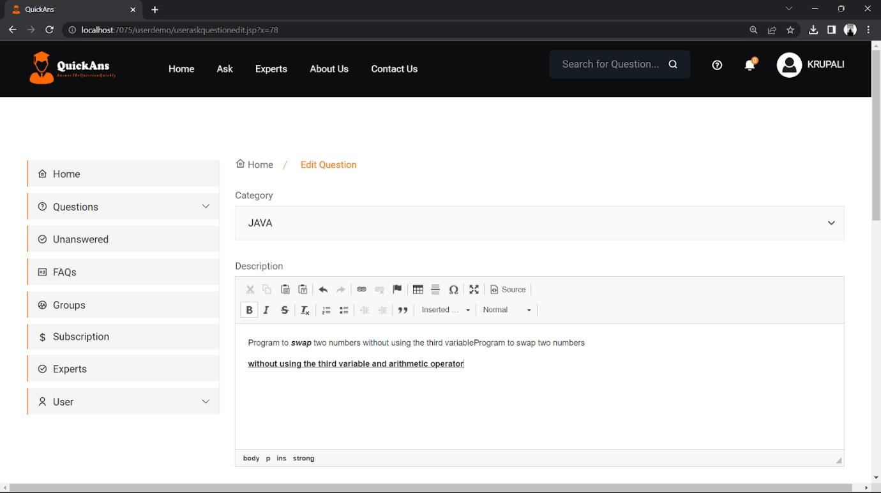

ANOTHER USER GIVE ANSWER TO THE

USER

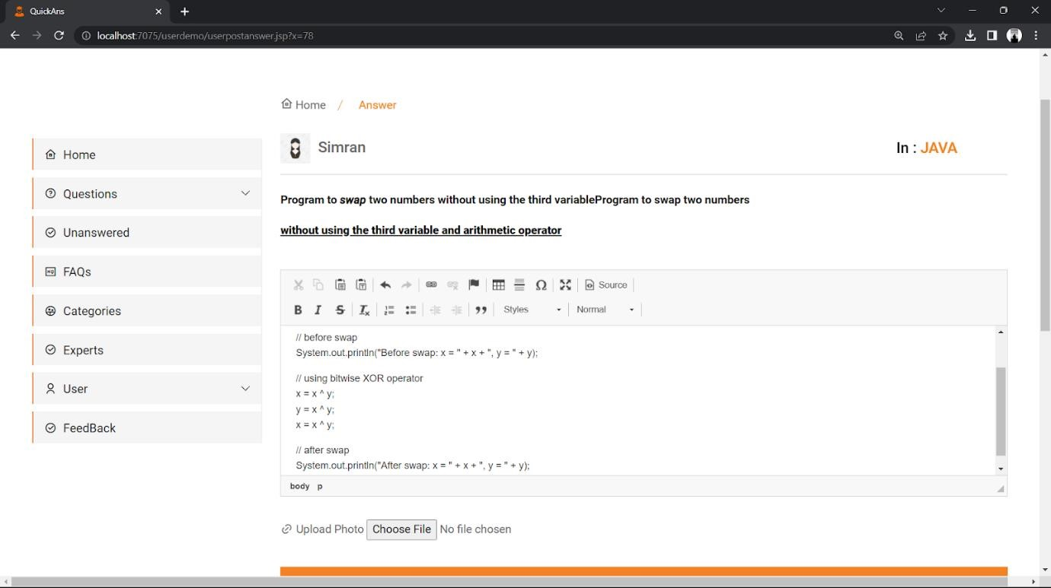

USER GET NOTIFICATION OF THE ANSWER

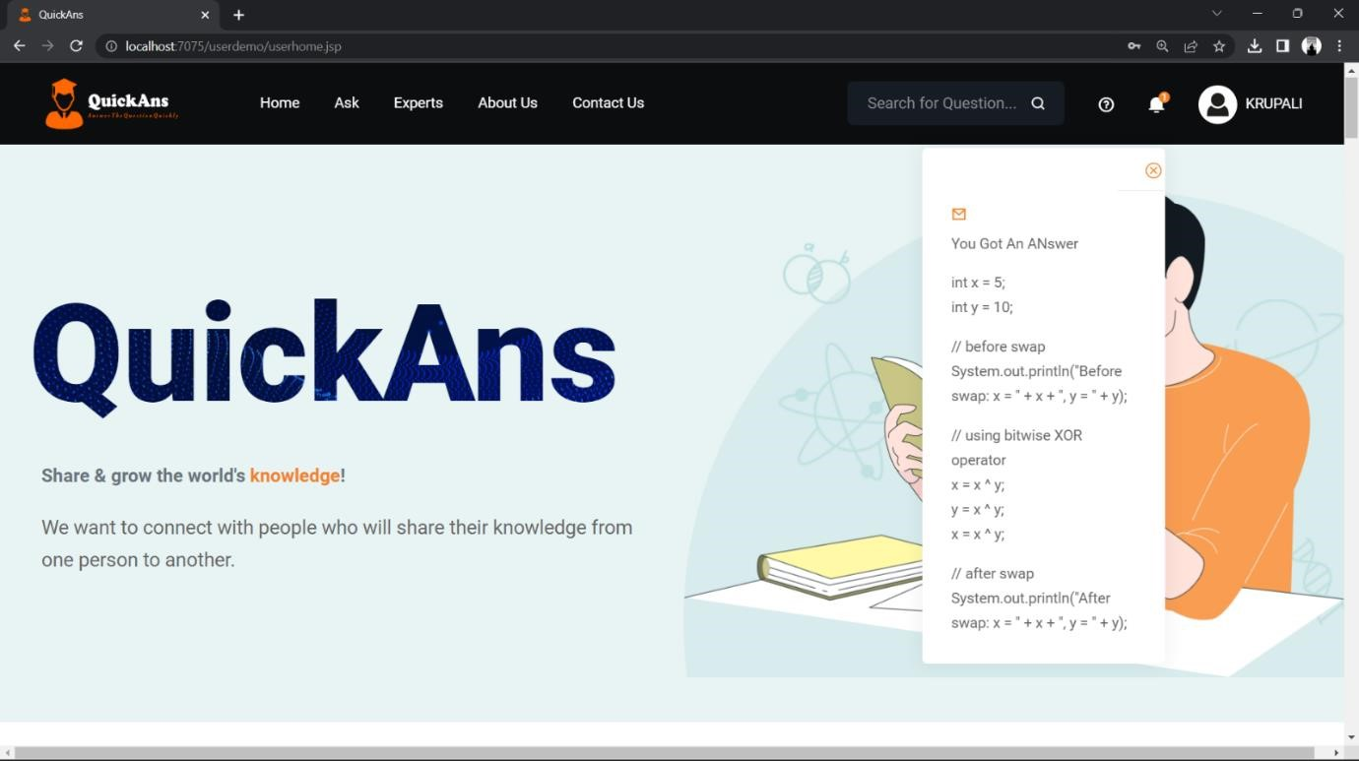

USER GET MAIL WHEN NOTIFIED

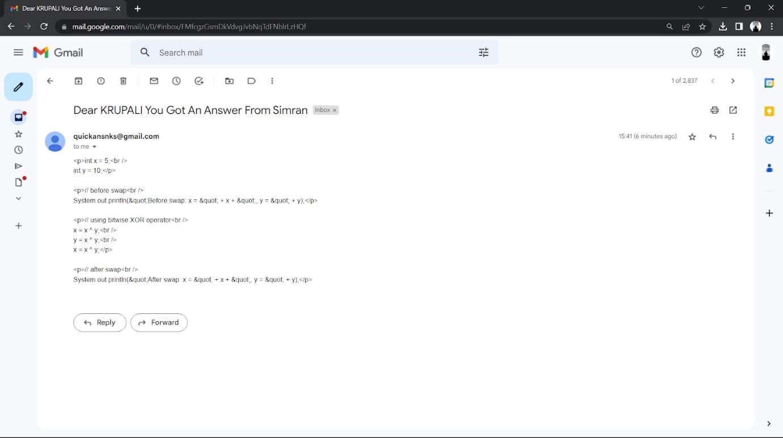

USER LIKED AN ANSWER

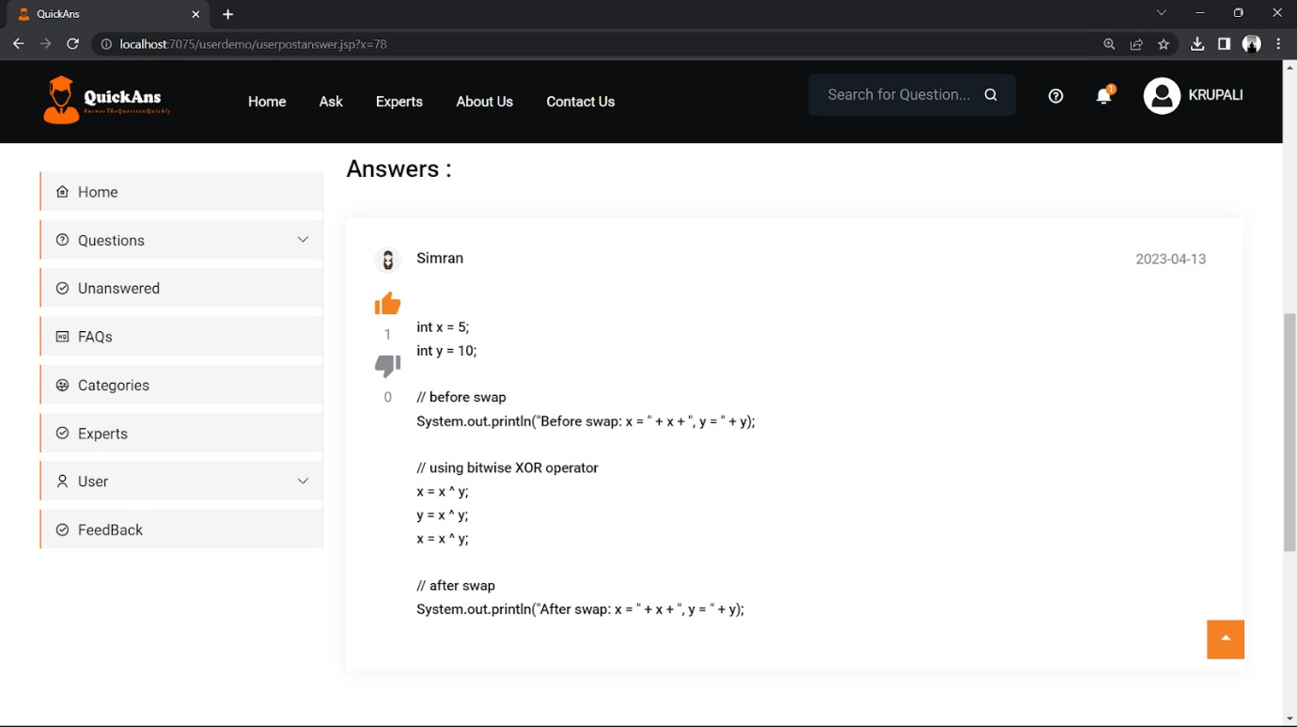

SEARCHING AN EXPERT PROFILE

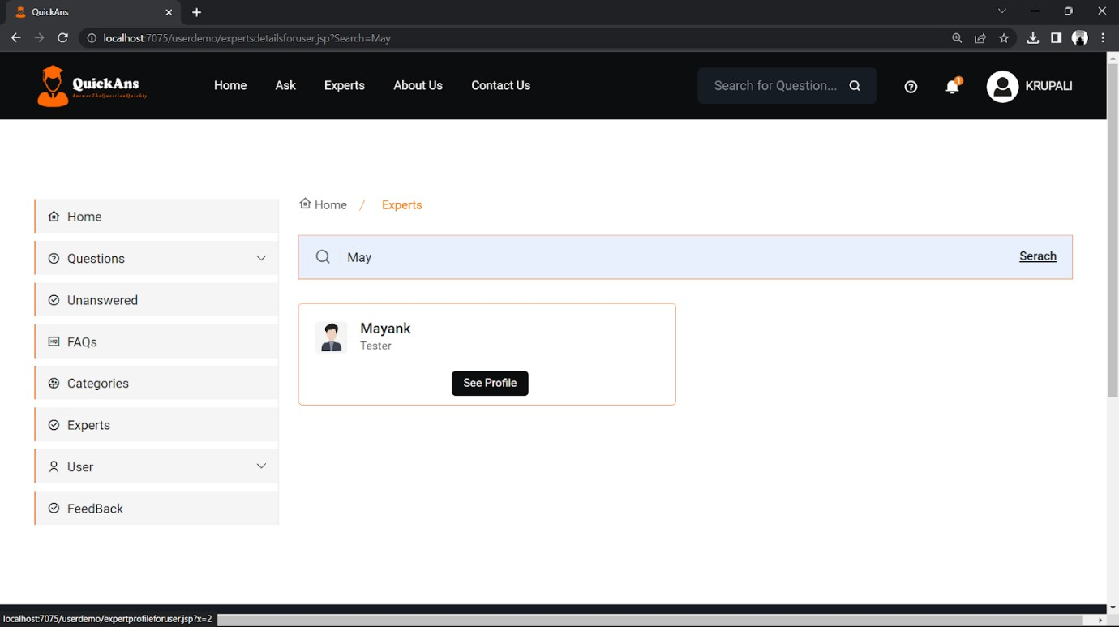

EXPERT PROFILE

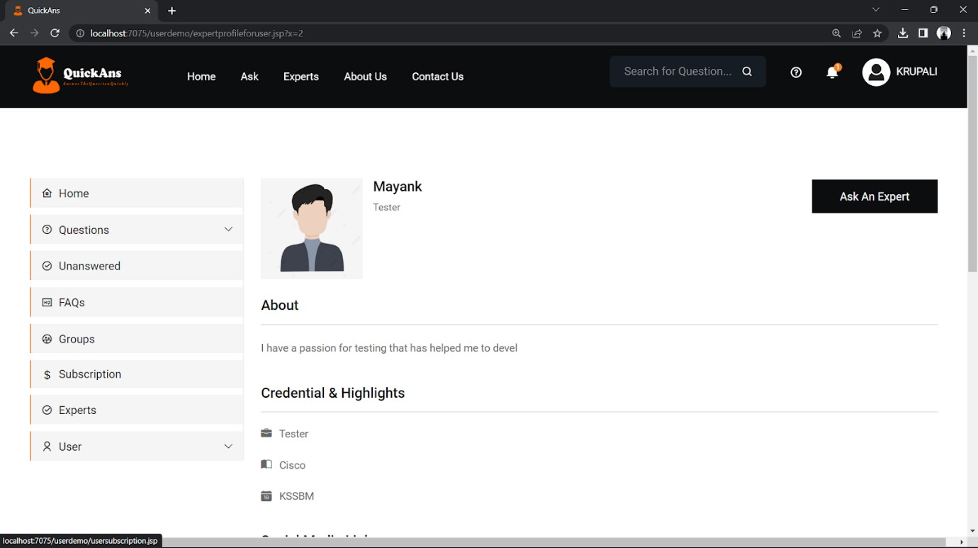

USER GETTING THE SUBSCRIPTION

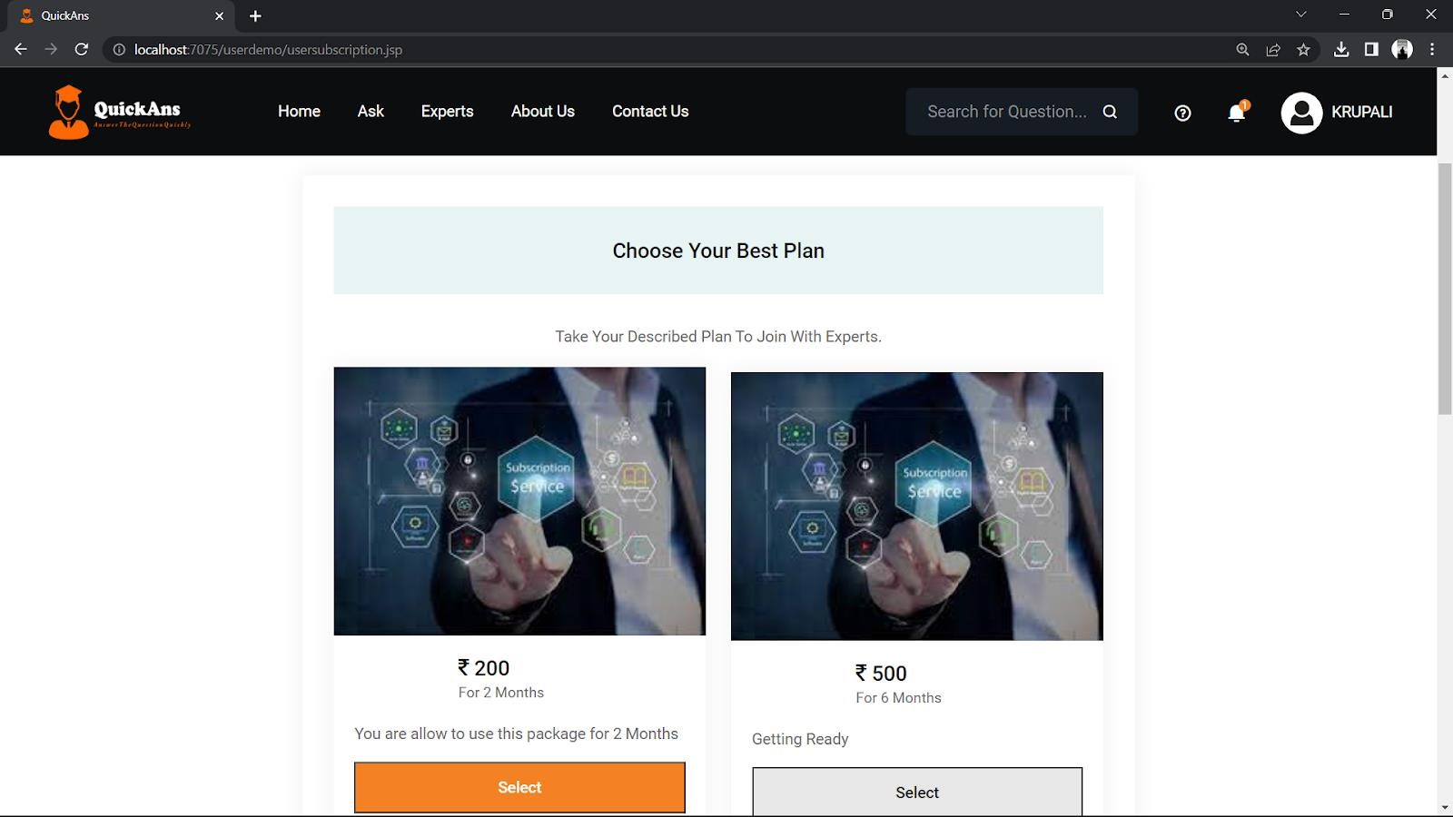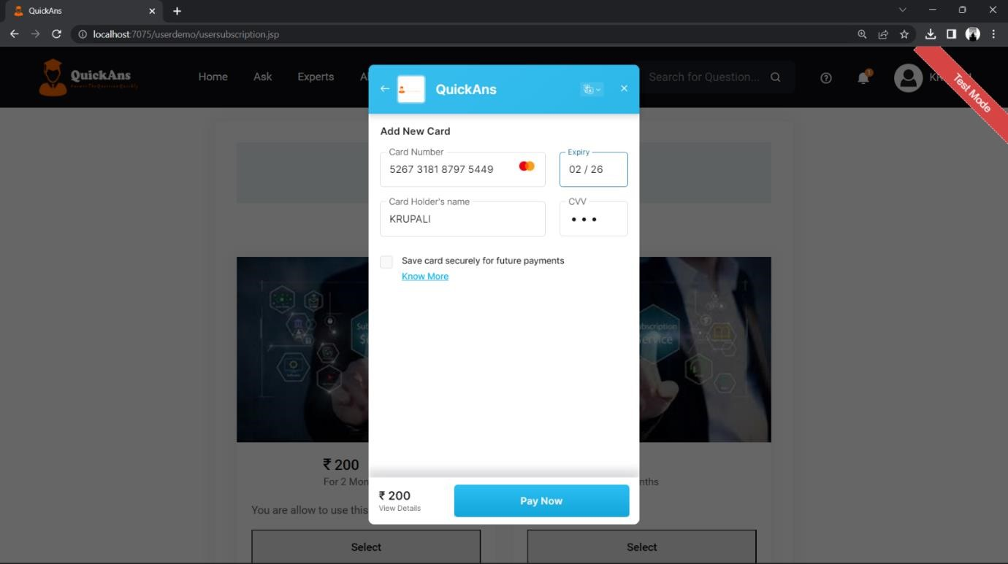

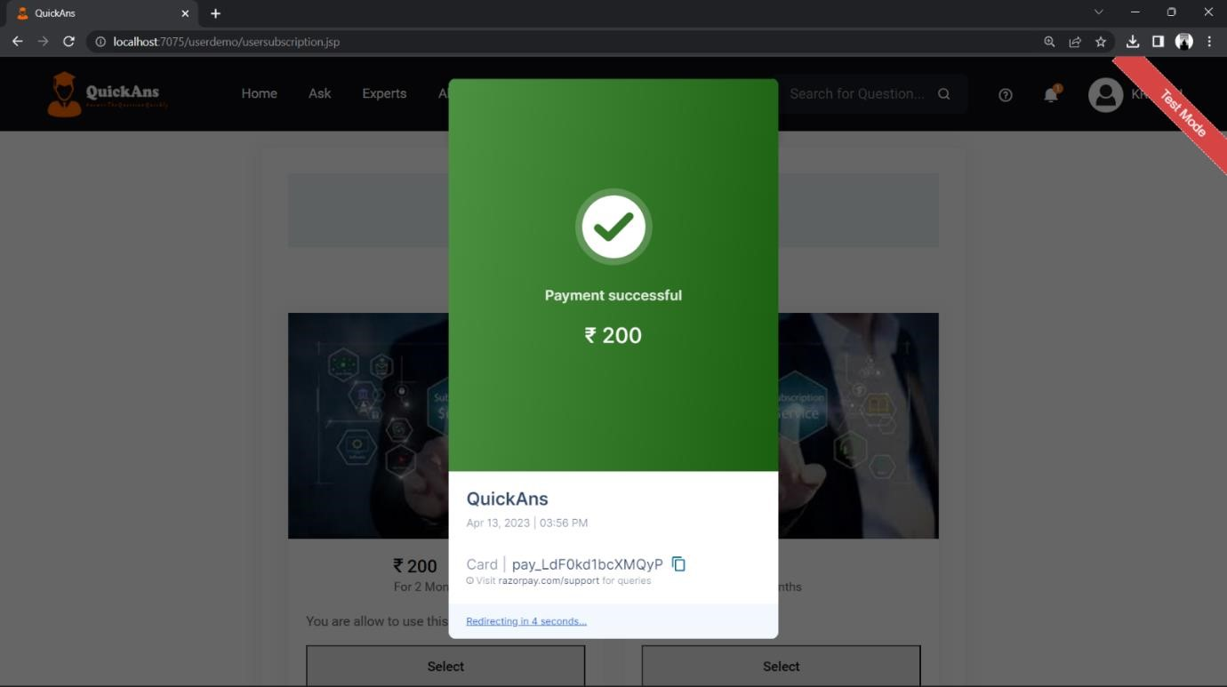

ASK QUESTION TO USER AFTER

SUBSCRIPTION

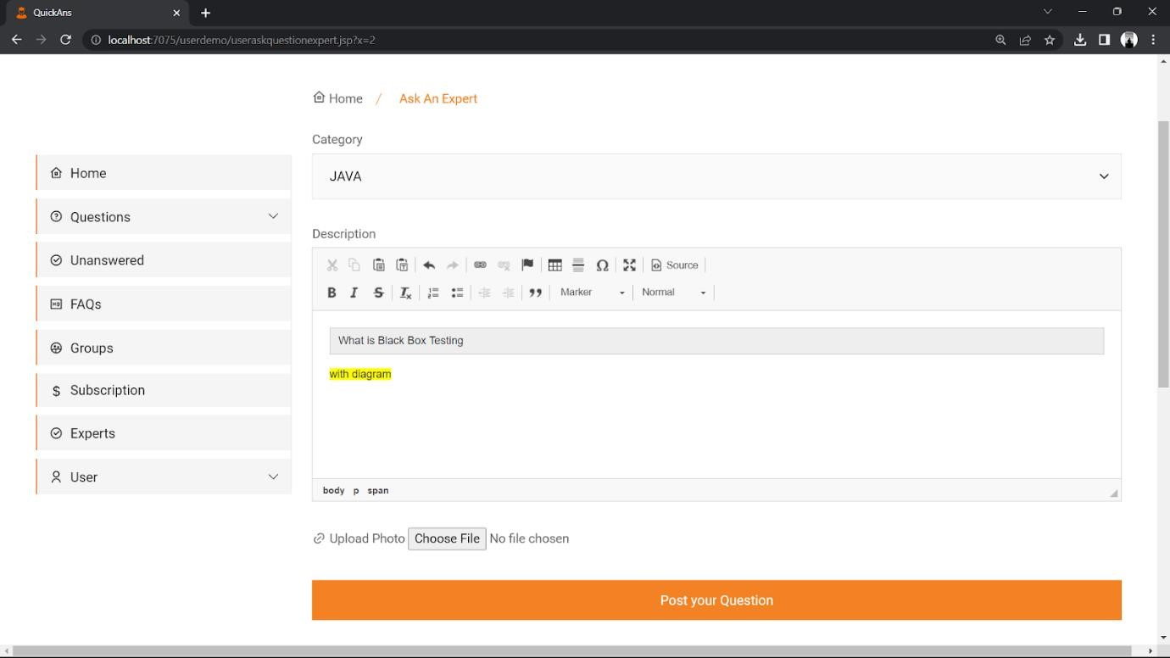

USER GET MAIL OF ANSWER

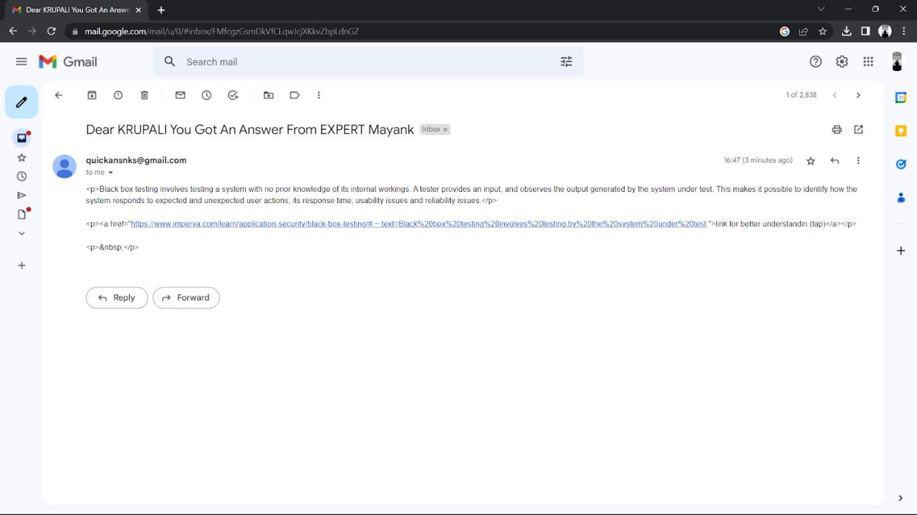

USER LIKED THE ANSWER

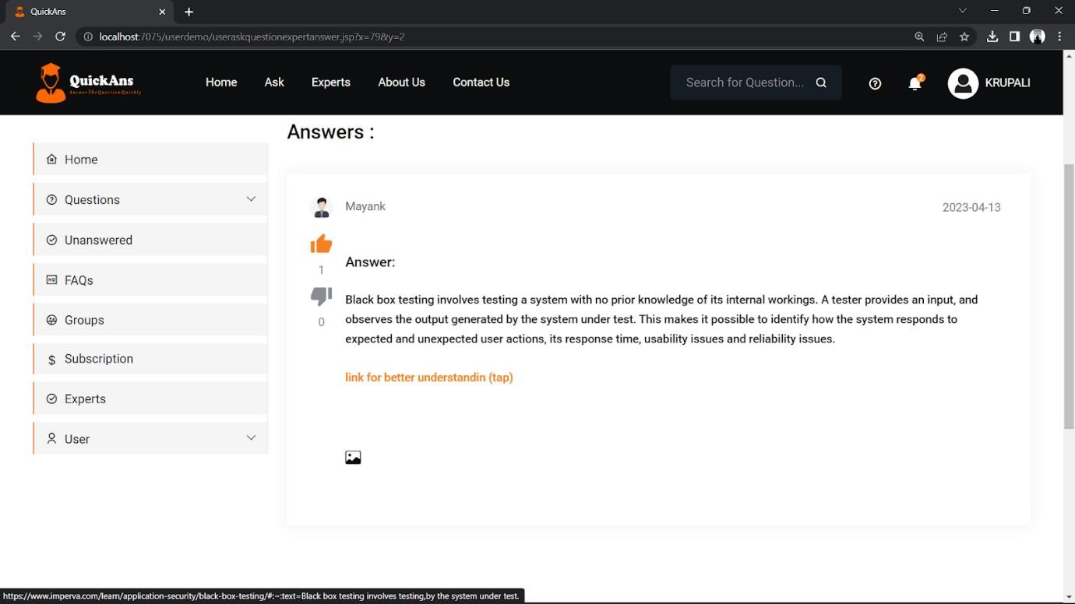

CONTACT US PAGE

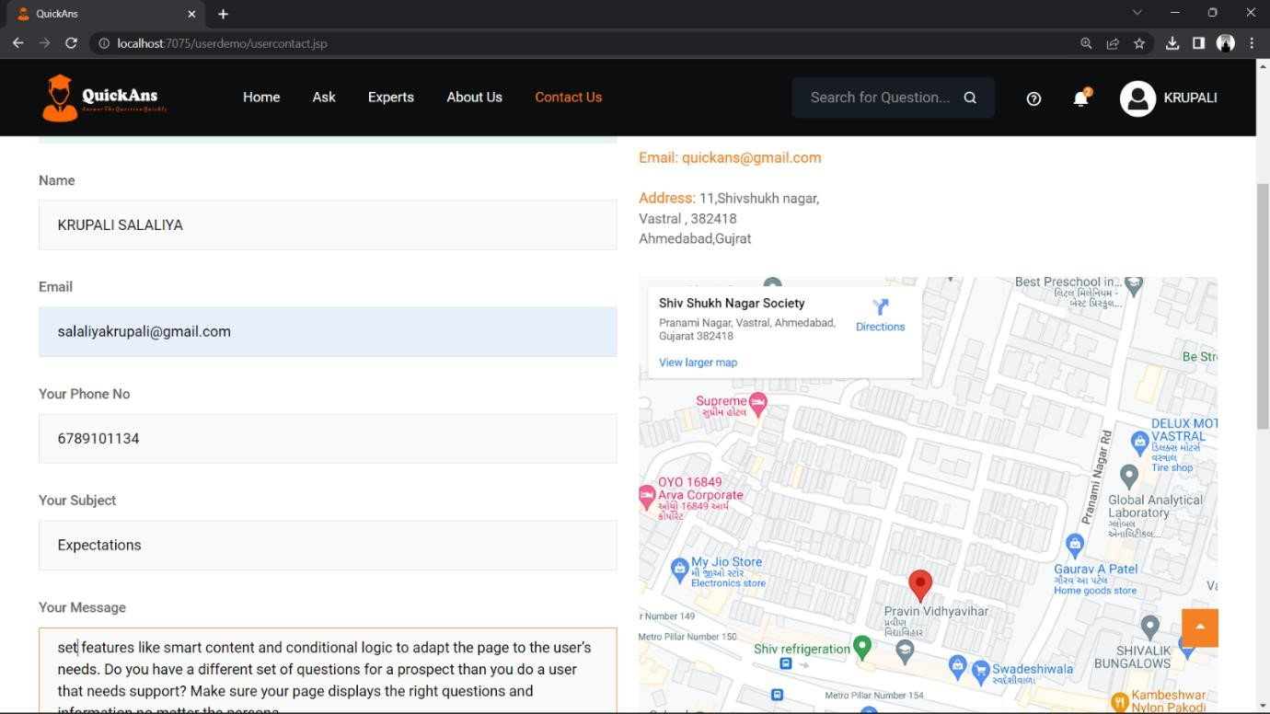

REPLY OF CONTACT US PAGE

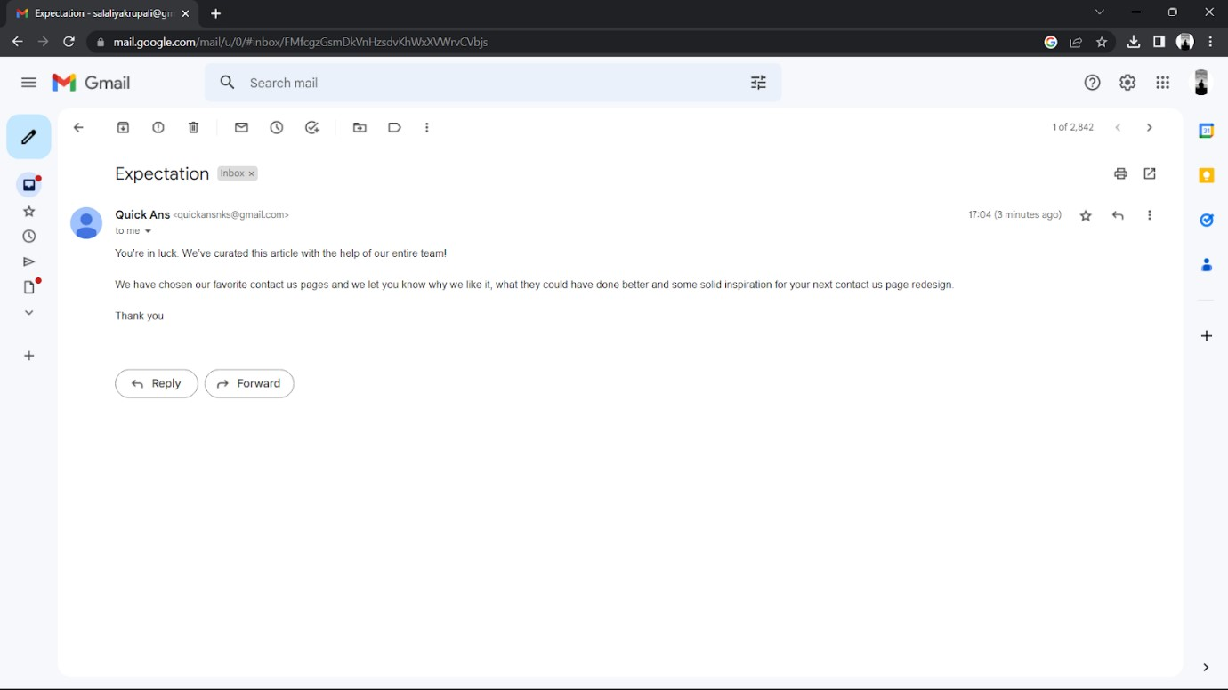

UPDATE PROFILE

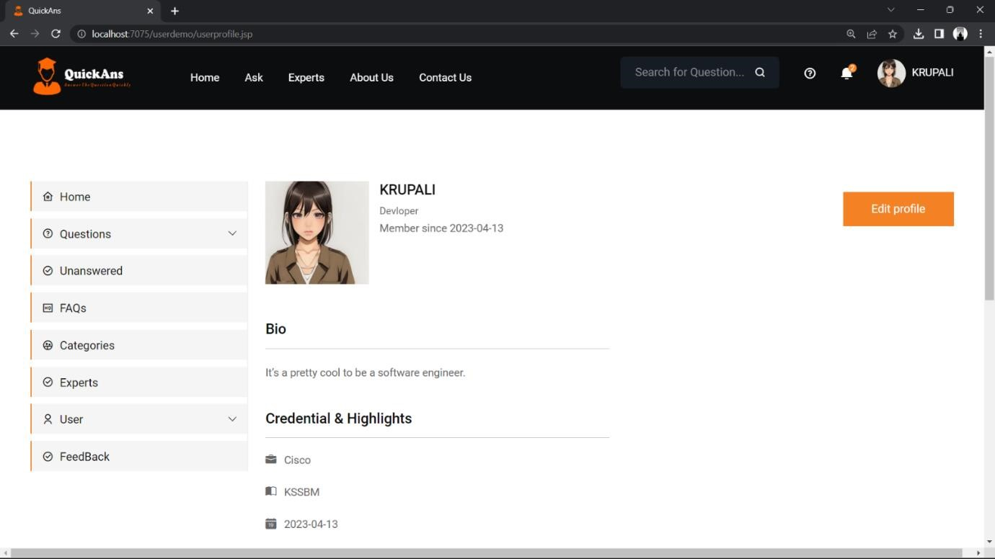

HOME PAPGE OF EXPERT USER

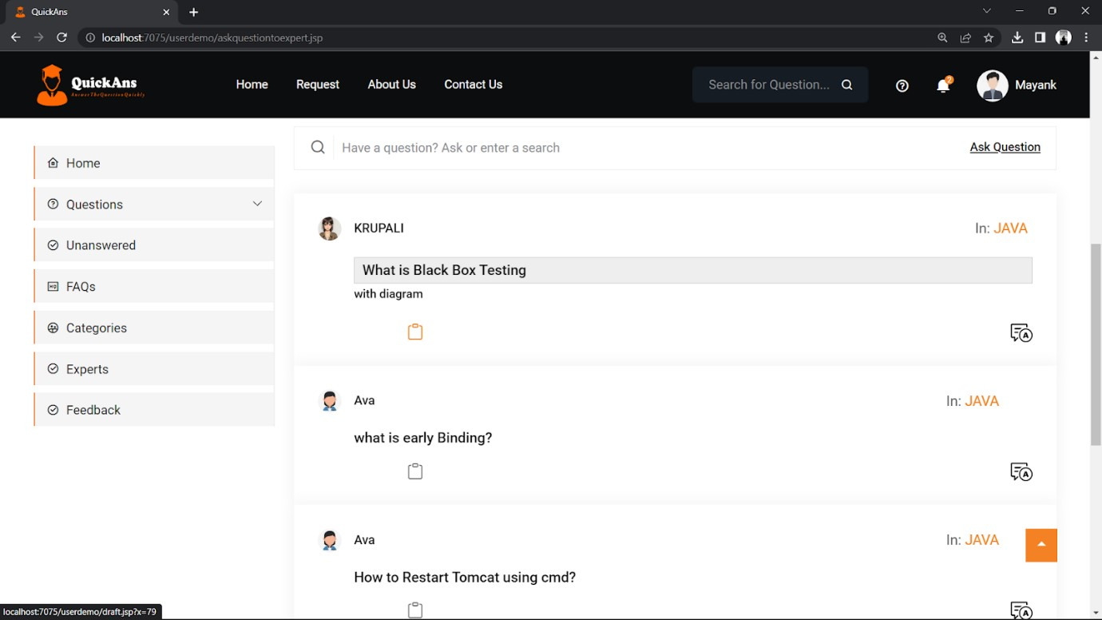

DRAFT ANSWER BY EXPERT USEER

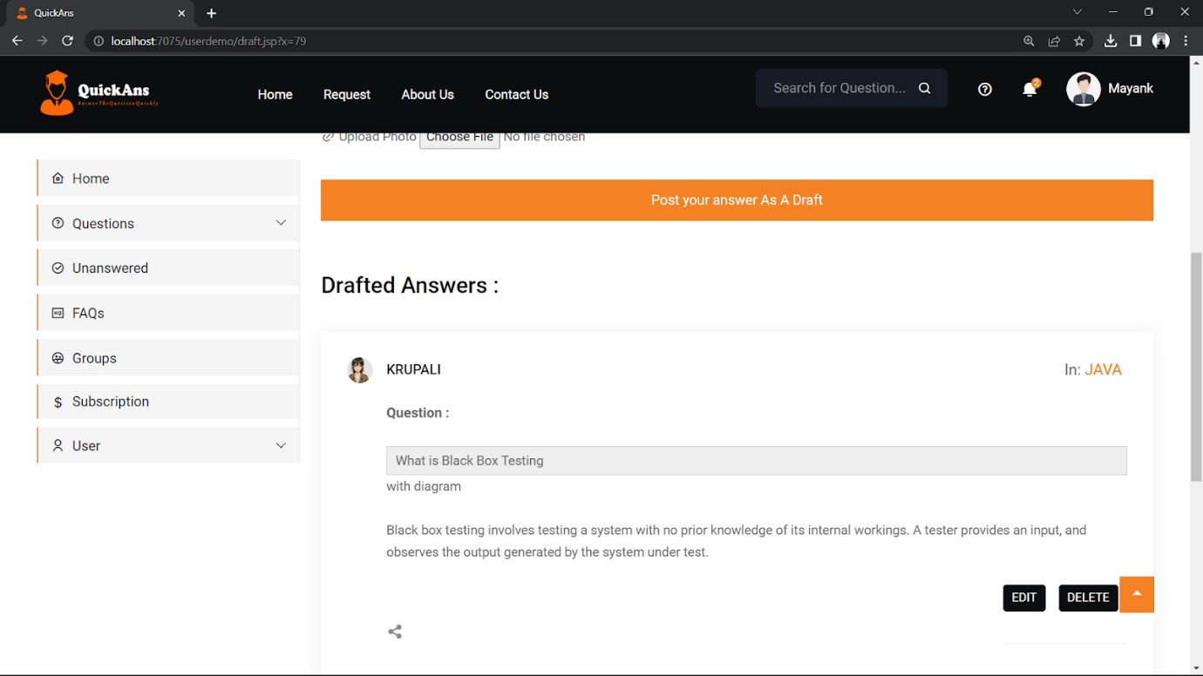

DRAFTED ANSWER

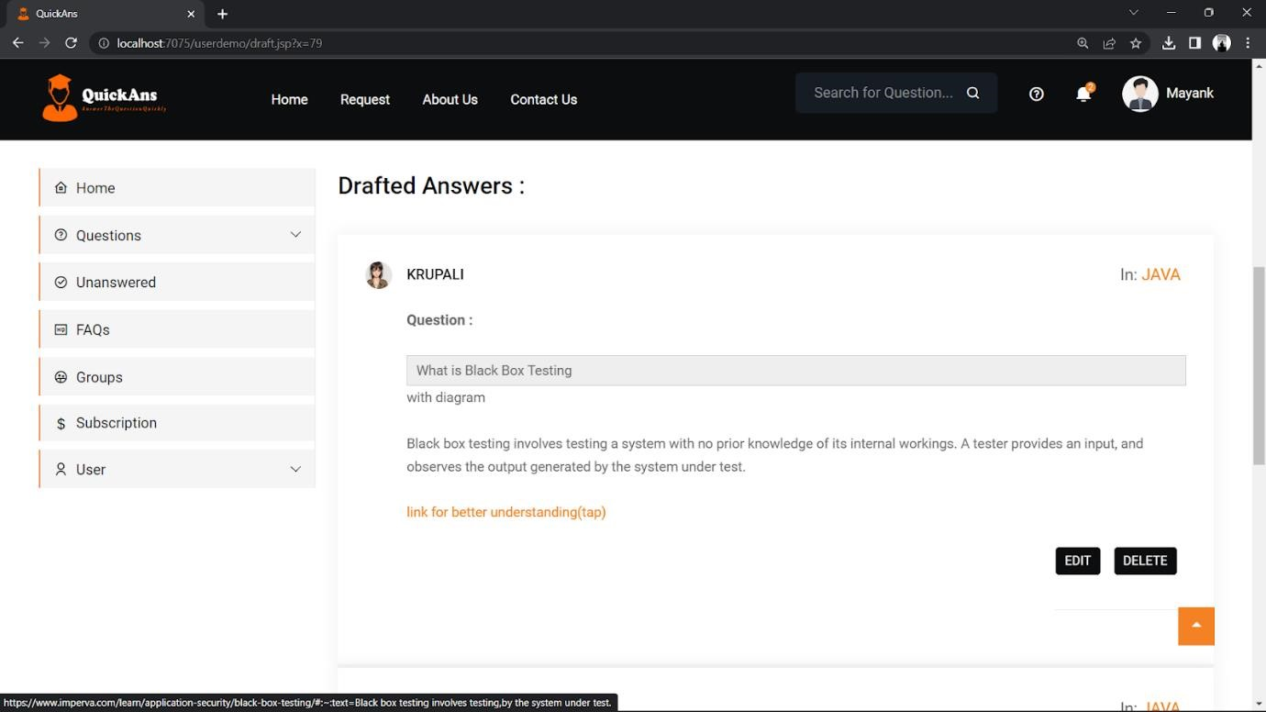

RATING OF EXPERT USER

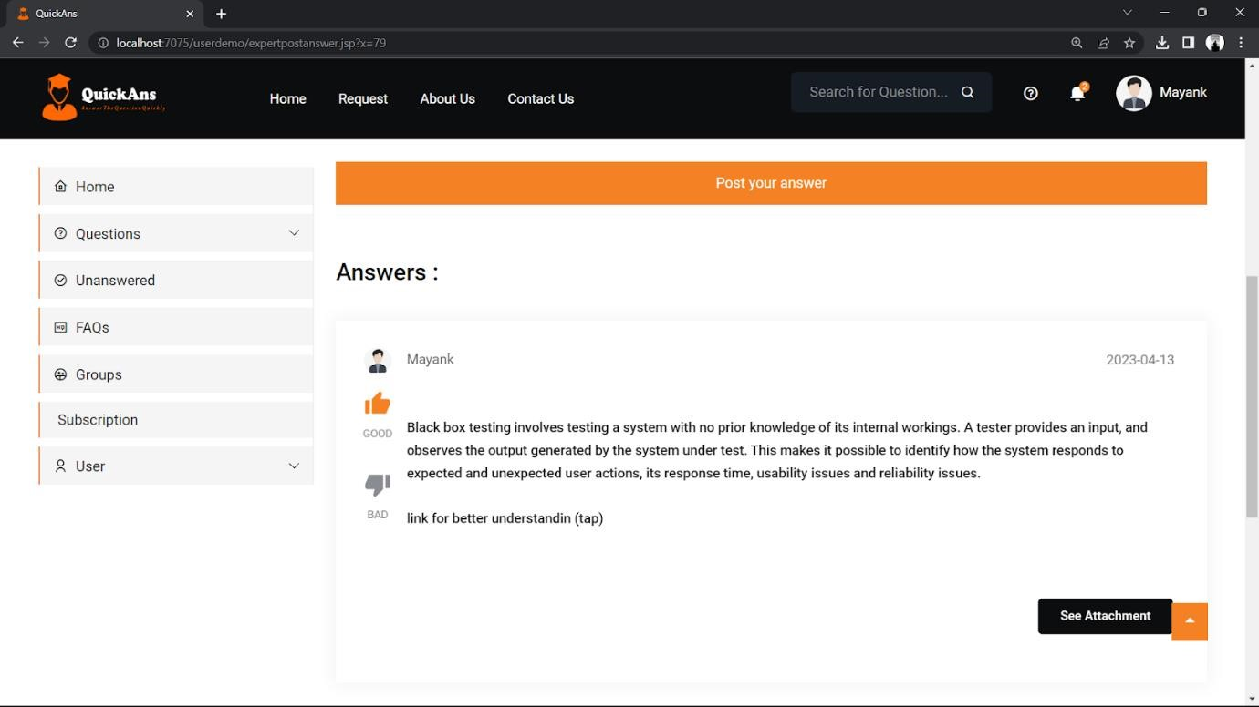

UPDATE PROFILE BY EXPERT USER

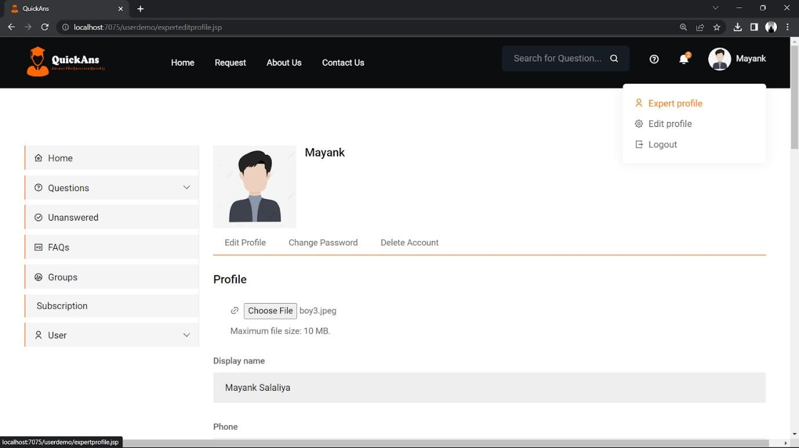

FEEDBACKK

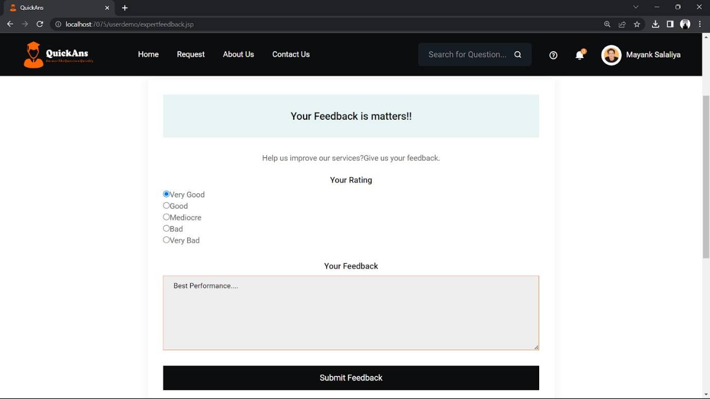

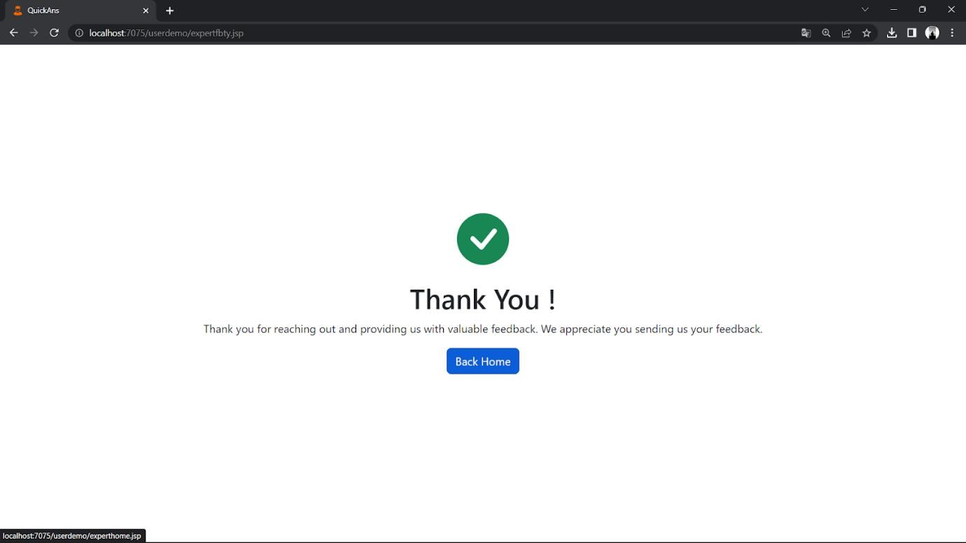

ADMIN INTERFACE

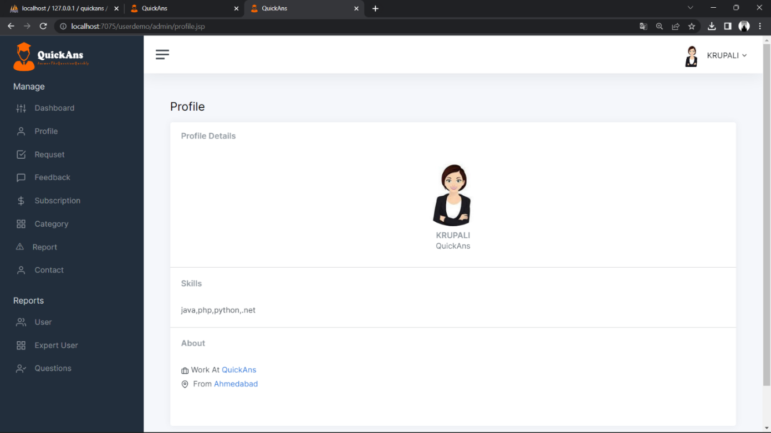

MANAGE EXPERTS

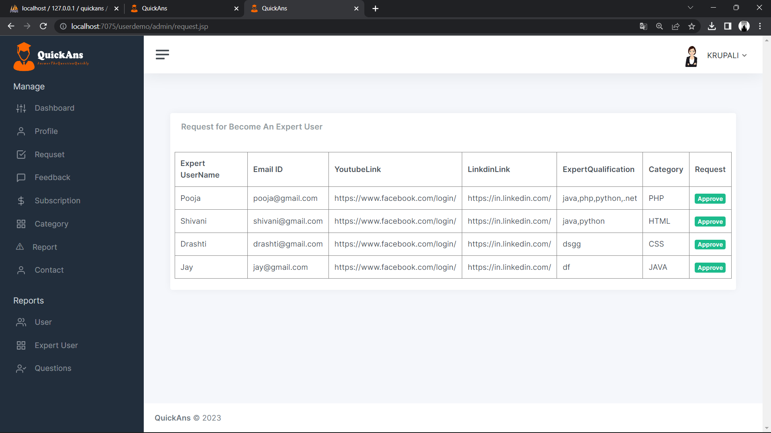

MANAGE SUBSCRIPTIONS

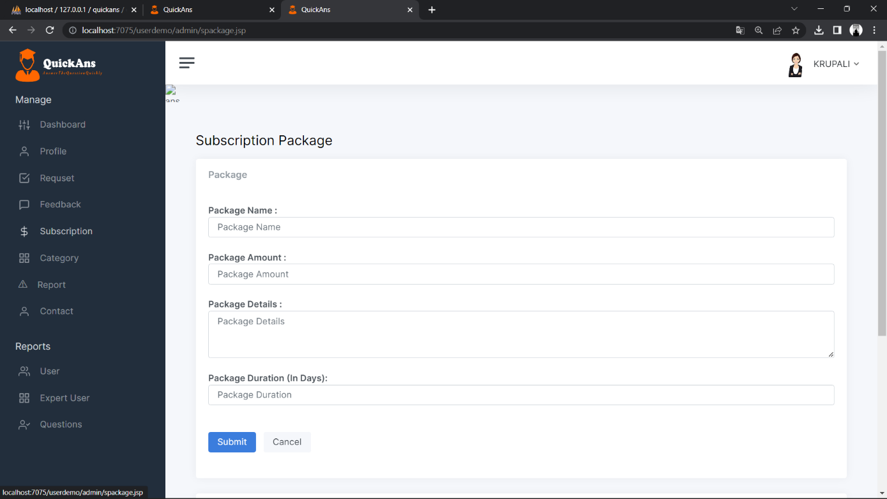

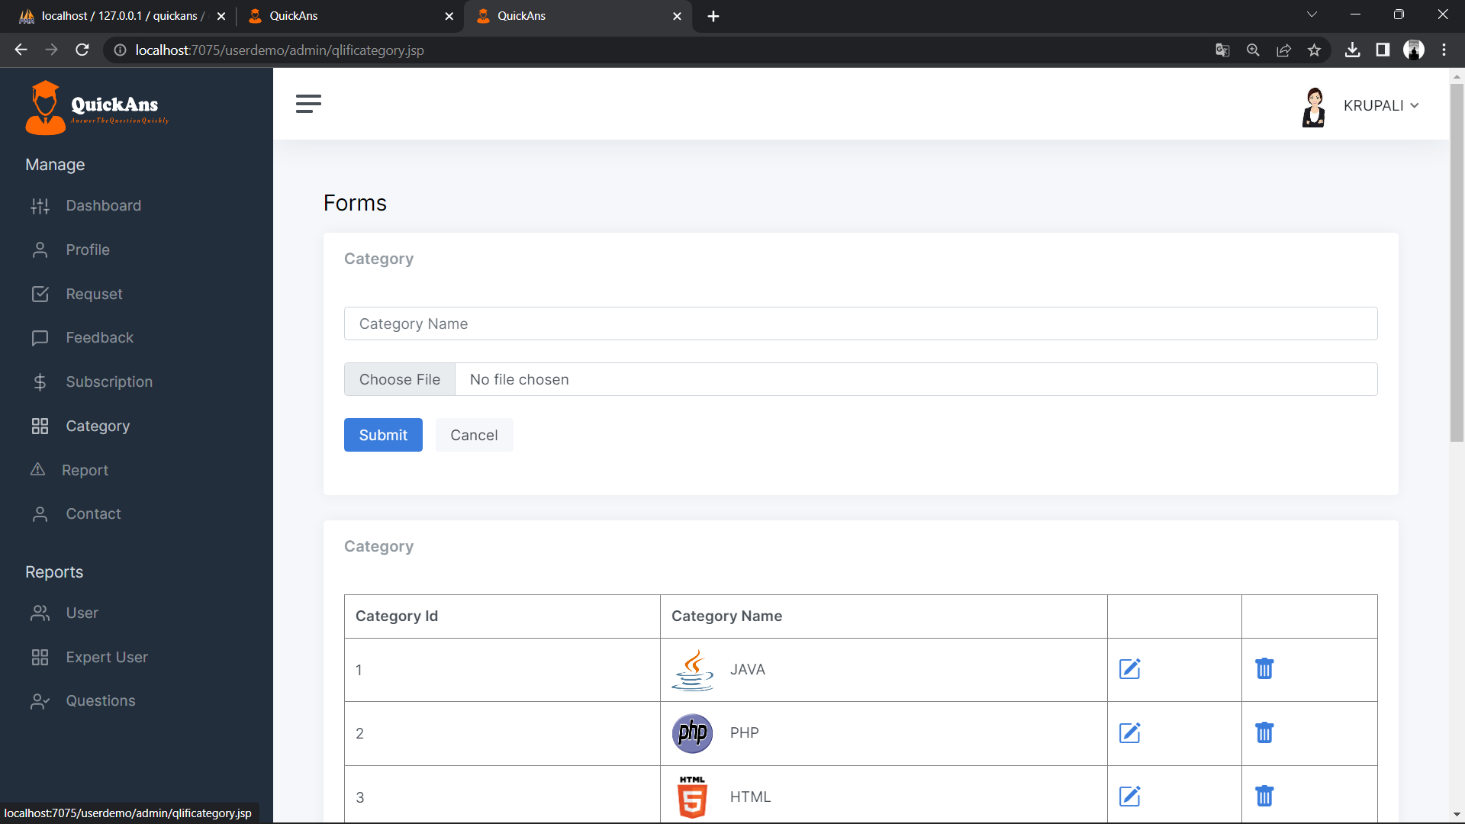MANAGE CATEGORY

MANAGE REPORTED QUESTIONS



MANAGE CONTACT

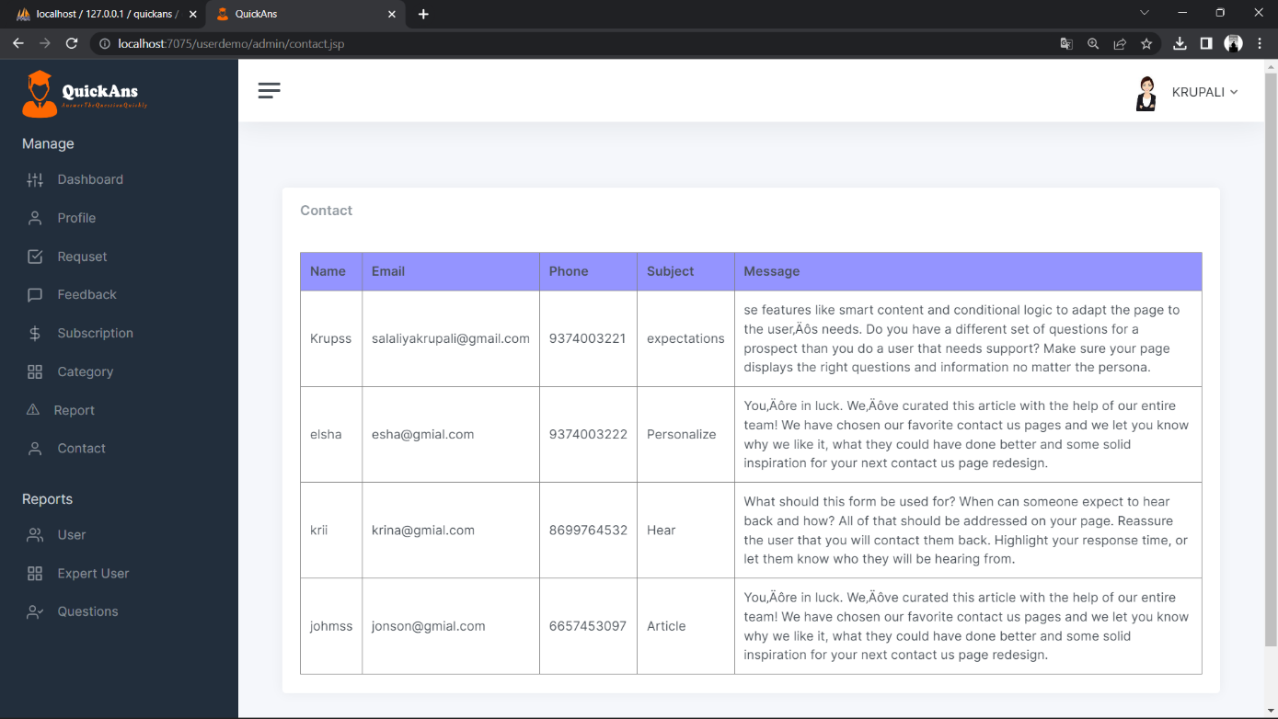

MANAGE CATEGORY WISE EXPERTS

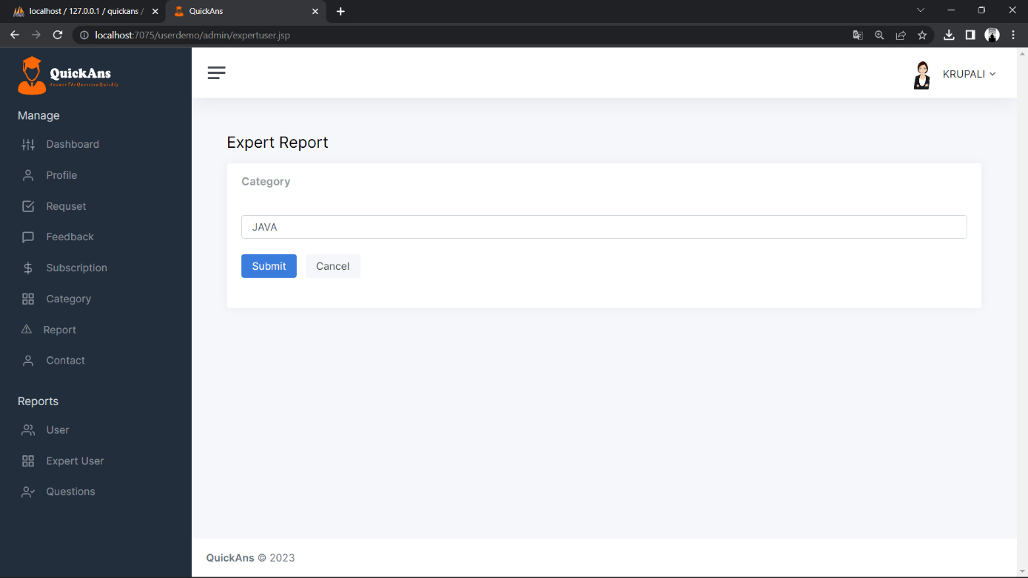

ADMIN DASHBOARD



VALIDATION

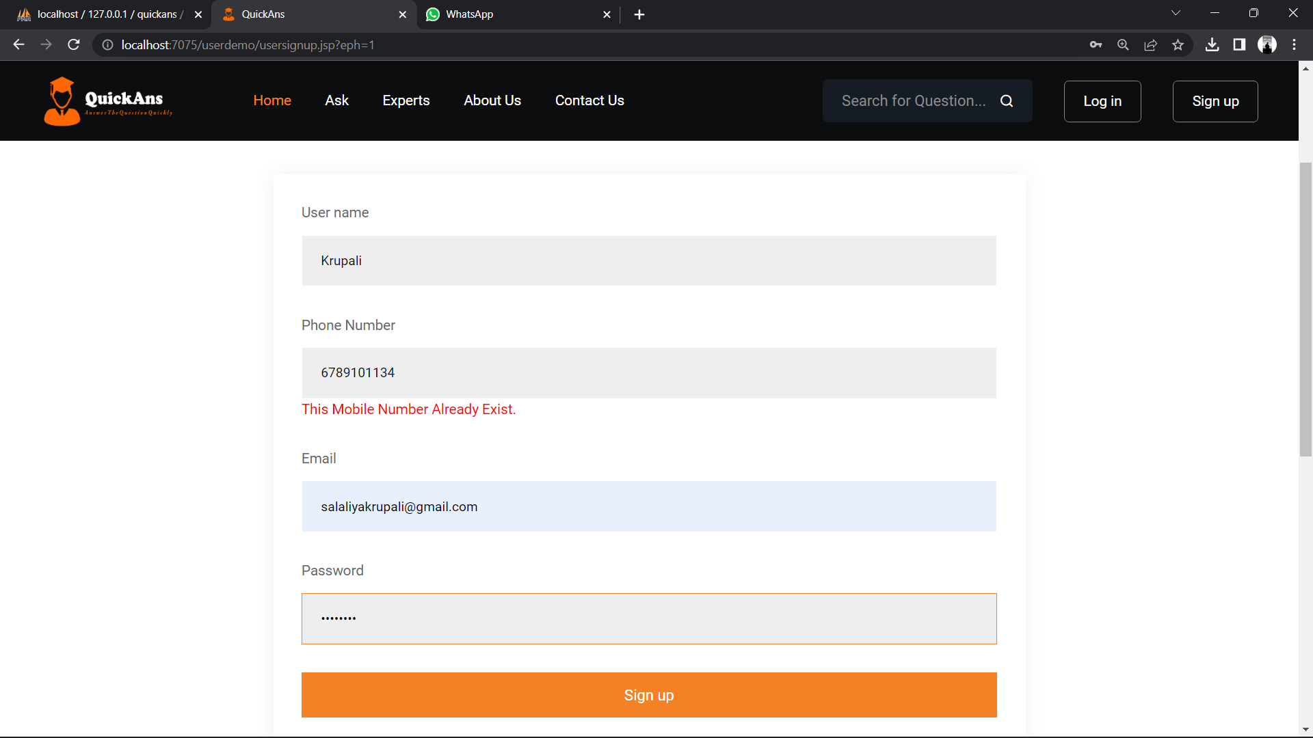PHONE NUMBER VALIDATION

OTP VALIDATION

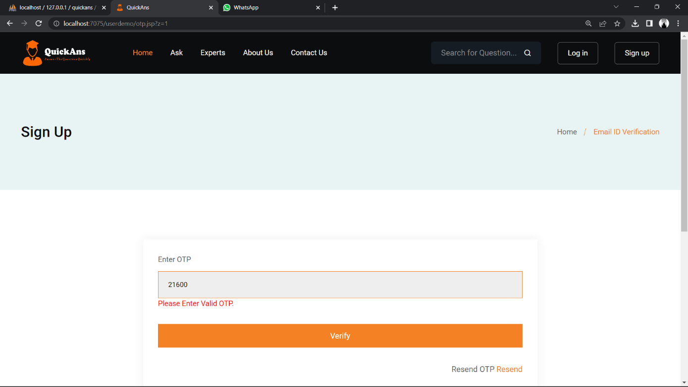

CHANGE PASSWORD

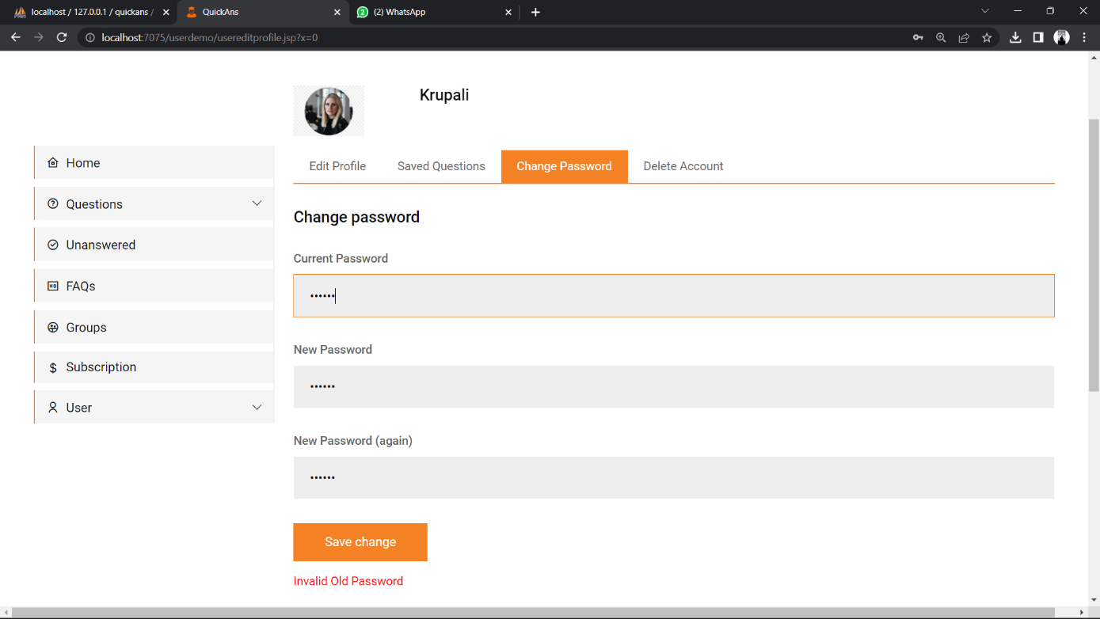

DELETE ACCOUNT

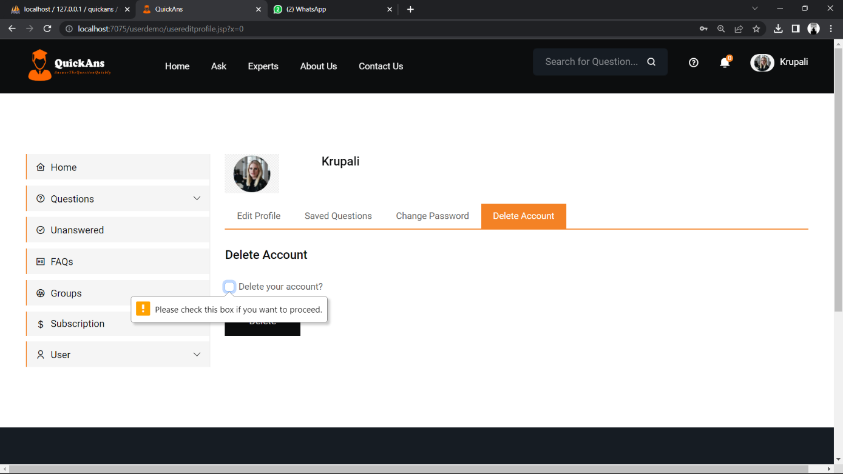

QUESTIONS SHOULD NOT BE EMPTY

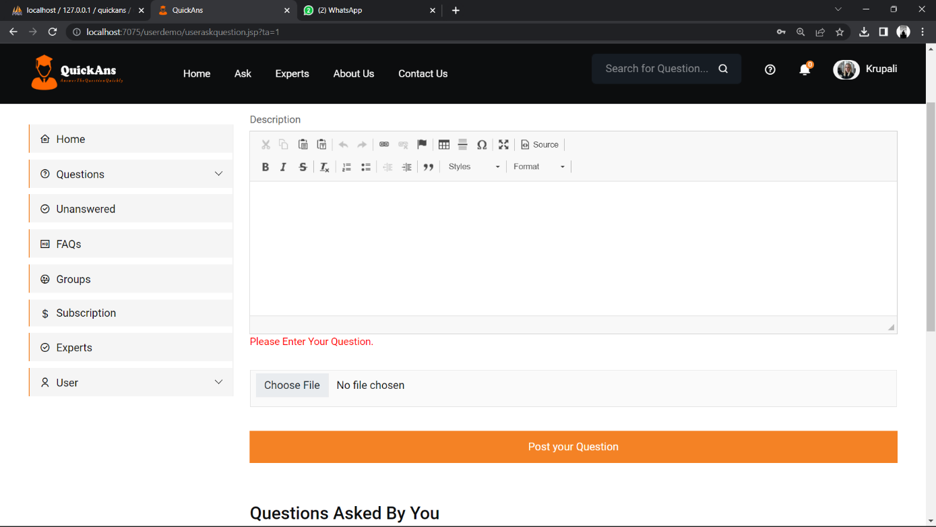

ANSWER BOX SHOULD NOT BE EMPTY

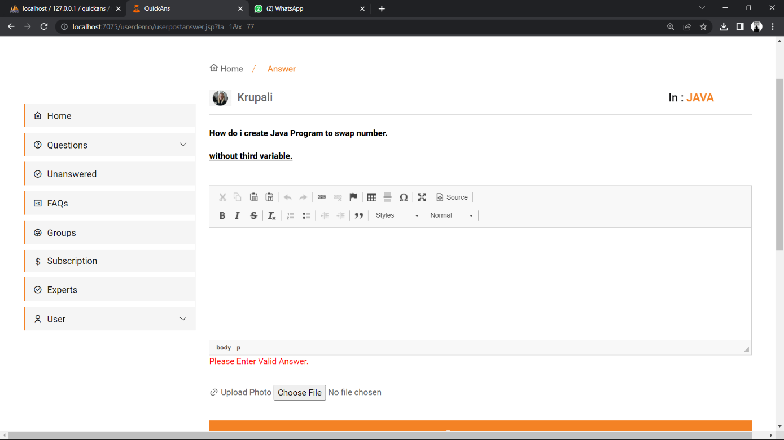

EMAIL MUST BE VALID

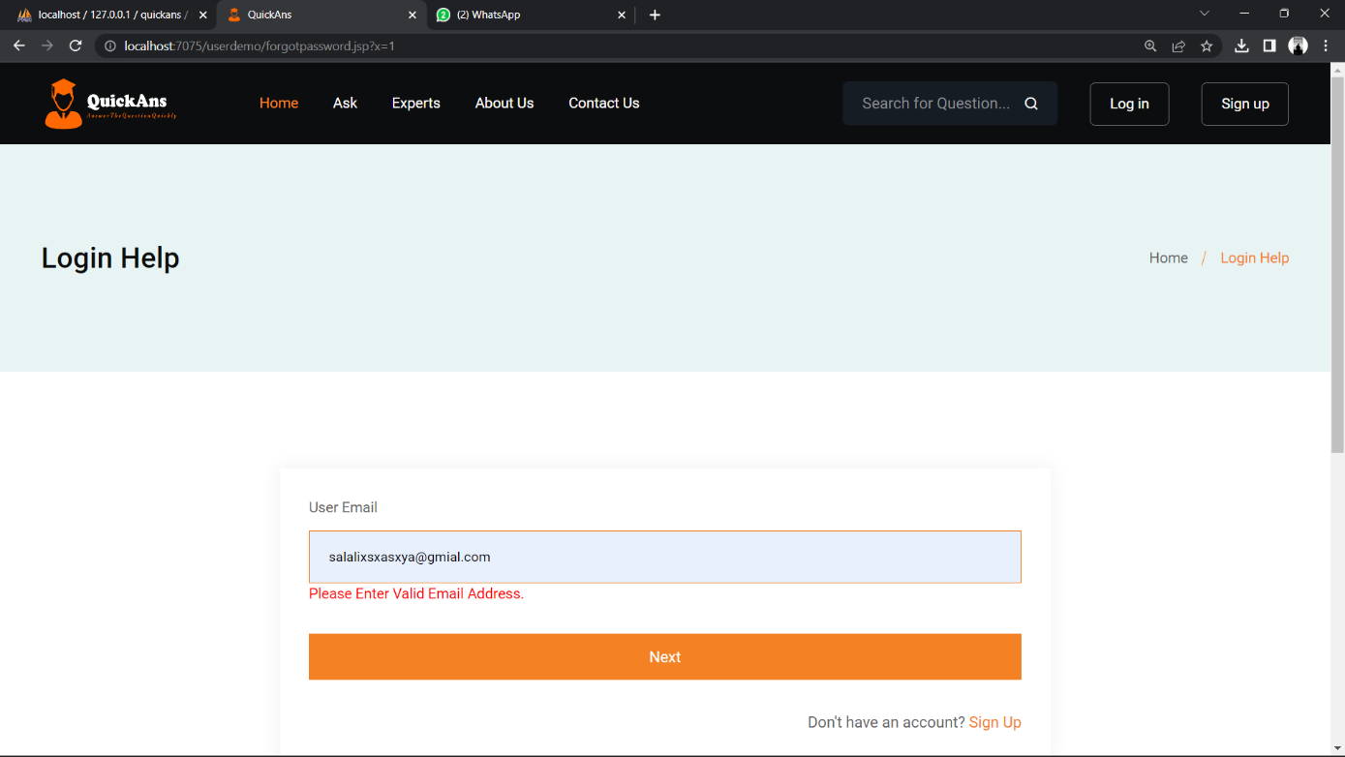

OTP LENGTH MUST BE 5

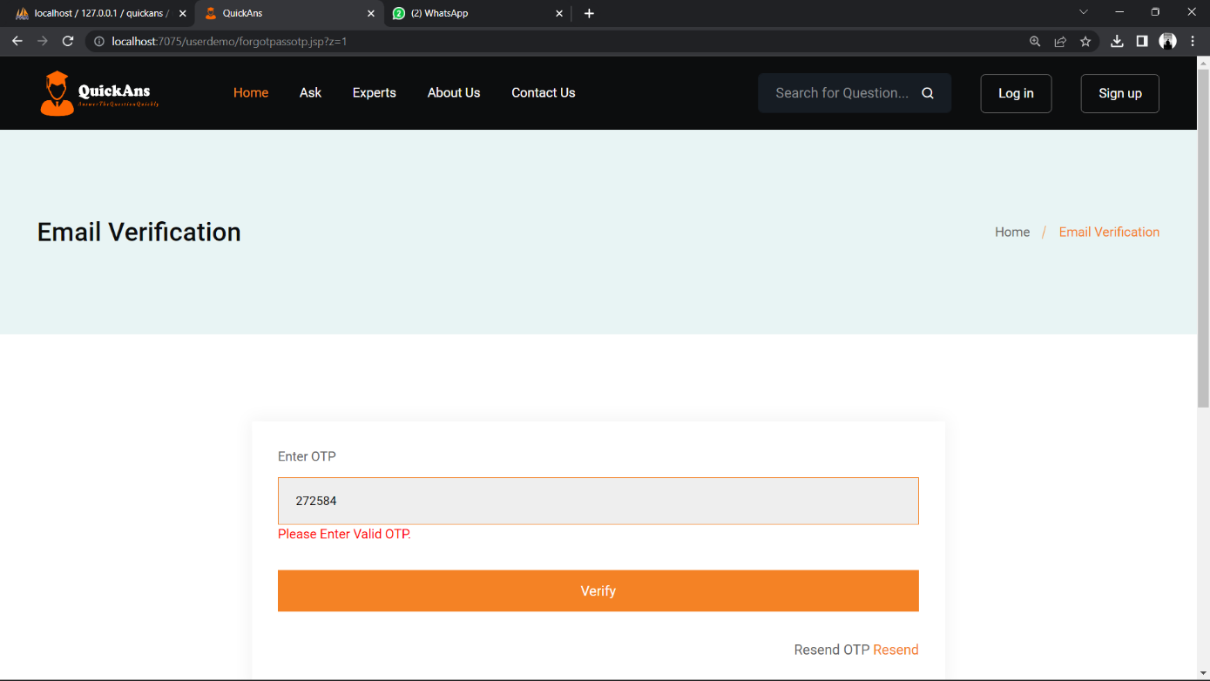

NEW PASSWORD AND OLD PASSWORD MUST MATCH

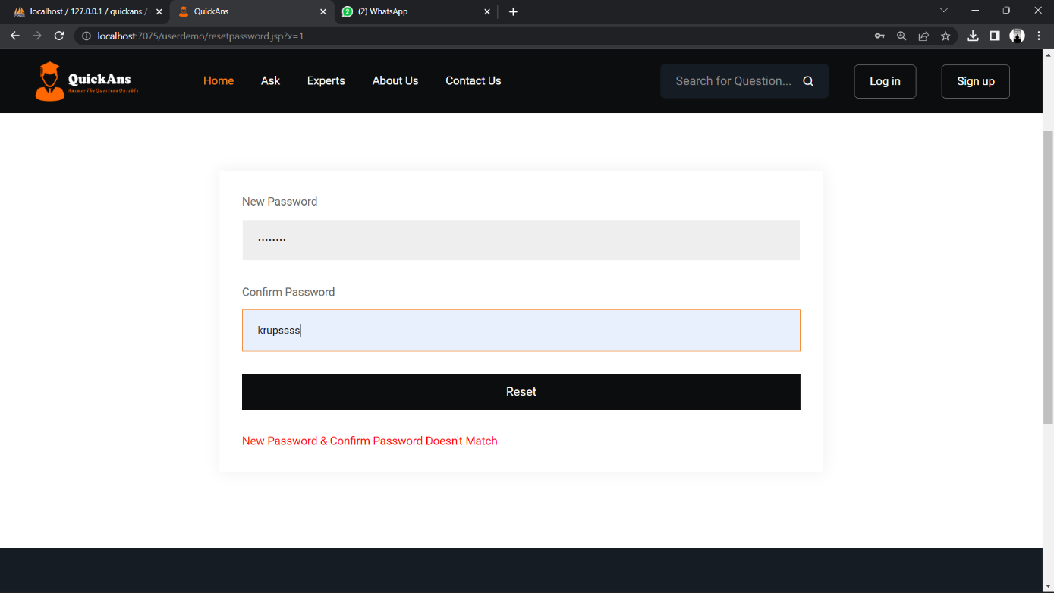

FEEDBACK FORM MUST NOT BE EMPTY

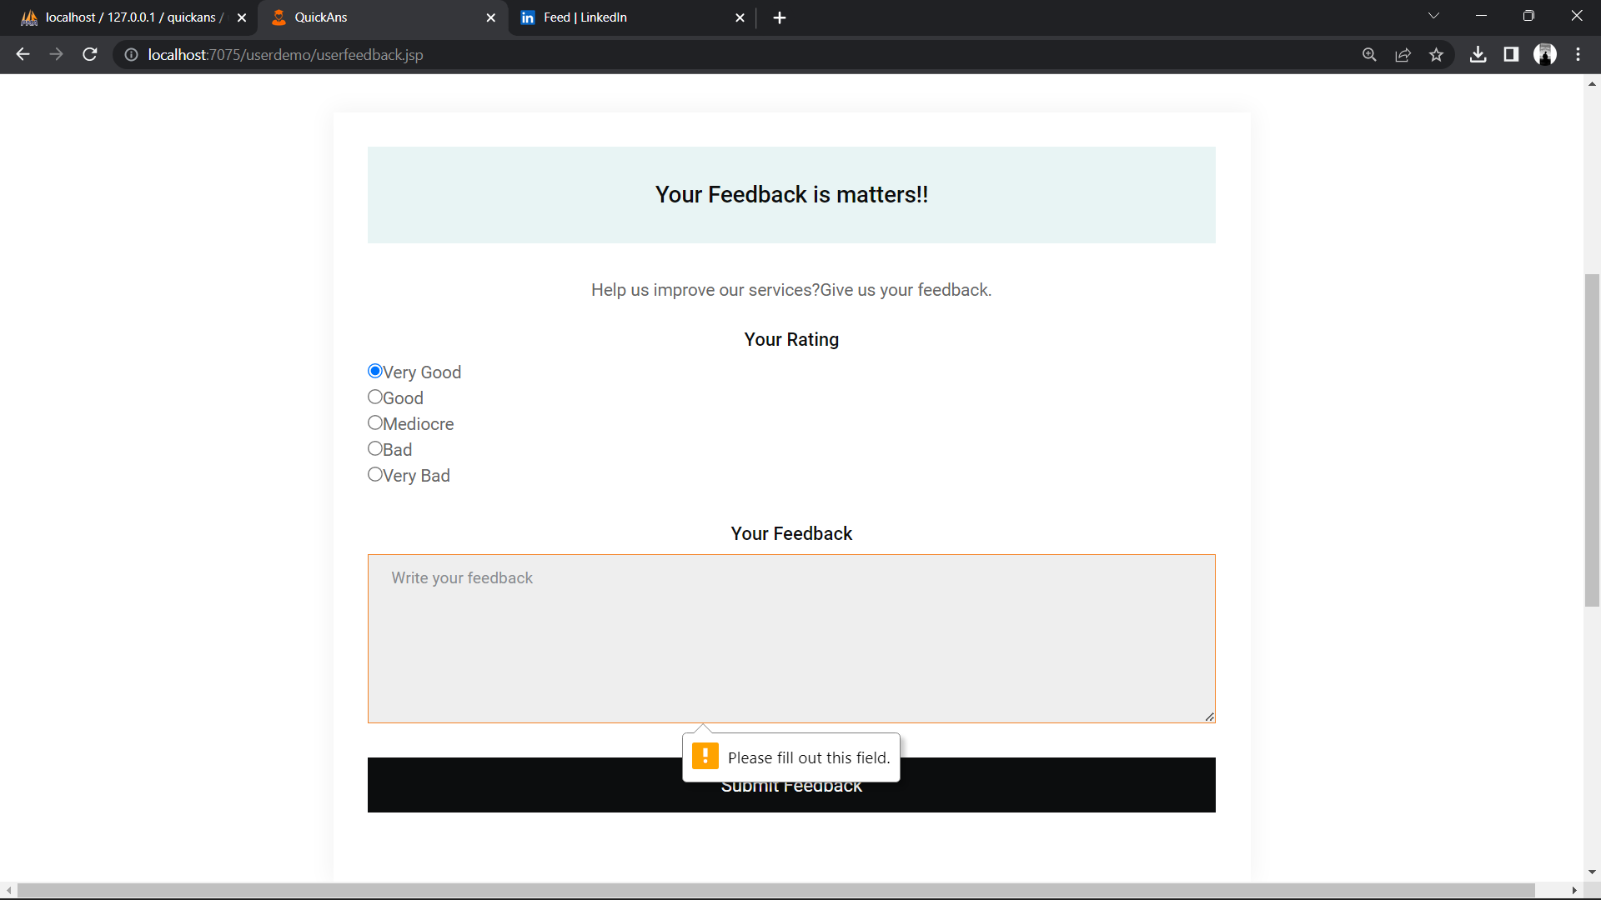

ASSUMPTIONS

* The Client should have the basic knowledge of how the online systems works.
* Proper Internet setup is required to run the system smoothly.
* Client should be having a valid Gmail id.
* Expert users will have enough knowledge and expertise to provide valuable answers to the registered users.

LIMITATIONS

* The website may face competition from other Q&A platforms, making it difficult to attract and retain users.
* It may be challenging to attract and retain expert users, especially if they are not sufficiently compensated or motivated.

FUTURE SCOPE

* Expert user will get paid according to their upvoted or rated answers.
* New Revenue related Services other than the existing services will be added to the system into the future.
* The system could be expanded to include additional features such as discussion boards, and social networking capabilities to encourage user engagement and collaboration.

CONCLUSION

* The System is stable enough to provide a platform for registered users to connect with expert users and get their questions answered, thus creating a knowledge-sharing community.
* The subscription model can generate revenue for the website, but it should be priced appropriately to attract and retain users.
* The website can be scaled up and expanded to include additional features and functionality to enhance the user experience.

BIBLIOGRAPHY

* [https://www.google.com](https://www.google.com/)
* [https://www.youtube.com](https://www.youtube.com/)
* [https://www.vlab.co.in](https://www.vlab.co.in/)
* [https://www.javatpoint.com](https://www.javatpoint.com/)